

Site Audit
www.client.com
[Date]

TABLE OF CONTENTS

TABLE OF CONTENTS 2
INSTRUCTIONS 7
Note About Links in Audit 7
Search/Replace Site Name 7
Investigation Notes 7
Update Audit Doc’s Branding 7
Data Pull for Audit 8
Tracking 9
Structured Markup 9
Miscellaneous 10
More 10
Prepare Data File 10
Create Google Spreadsheet with Breakdown of Issues 10
Audit Tools 12
Google Analytics (Required) 12
Google Webmaster Tools (Required) 12
Bing Webmaster Tools (Required) 12
Mozbar (Required) 13
Web Developer Toolbar (Required) 13
ahrefs (Required) 13
Moz (Optional) 13
Reverse Internet (Optional) 13
SEMRush (Optional) 13
SEO Site Tools 13
Barracuda’s Panguin Tool (Optional) 13
IIS SEO Toolkit (Optional) 14
Supermetrics (Optional) 14
EXECUTIVE SUMMARY 15
BREAKDOWN OF ISSUES 17
1.0 Content 17
1.1 Issues 17
1.2 Recommendations 24
2.0 Crawl 25
2.1 Issues 26
2.2 Recommendations 42
3.0 Sitemap 43
3.1 Issues 43
3.2 Recommendations 47
4.0 Robots.txt 48
4.1 Issues 48
4.2 Recommendations 51
5.0 Canonicalization 52
5.1 Issues 53
5.2 Recommendations 60
6.0 Architecture 61
6.1 Issues 62
6.2 Recommendations 65
7.0 Internal Links 67
7.1 Issues 69
7.2 Recommendations 75
8.0 Inbound Links 76
8.1 Issues 76
8.2 Recommendations 84
9.0 Semantic Markup 85
9.1 Issues 86
9.2 Recommendations 88
10.0 Images 89
10.1 Issues 89
10.2 Recommendations 91
11.0 Video 92
11.1 Issues 94
11.2 Recommendations 98
12.0 Titles 99
12.1 Issues 100
12.2 Recommendations 103
13.0 Meta Descriptions 104
13.1 Issues 105
13.2 Recommendations 106
14.0 Site Speed 107
14.1 Issues 108
14.2 Recommendations 111
15.0 Mobile 112
15.1 Issues 114
15.2 Recommendations 122
16.0 International 124
16.1 Issues 124
16.2 Recommendations 128
17.0 Business 129
17.1 Issues 129
17.2 Recommendations 129
18.0 Social 130
18.1 Issues 130
18.2 Recommendations 140

INSTRUCTIONS

Note About Links in Audit
Sometimes — especially on the Mac — longer links that are embedded in text won’t open from Word. If this happens, click the link, then press Ctrl-K (Mac: Command-K) to edit the link, and copy/paste it into a browser.

Search/Replace Site Name
This template references [CLIENT] all throughout. It can easily be replaced with your client or site’s name by using Ctrl/Command-F. You could either use the name (e.g., Annielytics) or the domain (e.g., annielytics.com) — whichever you’re more comfortable with. Just search and replace all references in one fell swoop.

Investigation Notes
I have included notes throughout the audit with instructions on things to investigate and how to do those investigations. They will be flagged with the word [INVESTIGATE], which will also be highlighted in yellow. If there is just one paragraph of notes, there will be one flag. If there is more there will be two. The second will say [/INVESTIGATE].
After you use the note, you should delete it so that it’s not included in the audit. These are only for the benefit of the auditor, not the recipient of the audit. You get to look like a total badass, and no one ever has to know I walked you through each step of the audit. :)
You’ll just want to do a search when you’re finished writing the audit to make sure you deleted all of these notes. #voiceofexperience

Update Audit Doc’s Branding
This template uses styles. You should modify the styles for all of the headings, hyperlinks (remember the visited style too), bullets, etc. To do that using Word 2013 follow these instructions. And for 2011 for Mac follow these instructions.
My favorite method is to change a Heading 2 snippet of text, for example, then right-click on it in the Styles section and choose Update to Match Selection from the contextual menu.
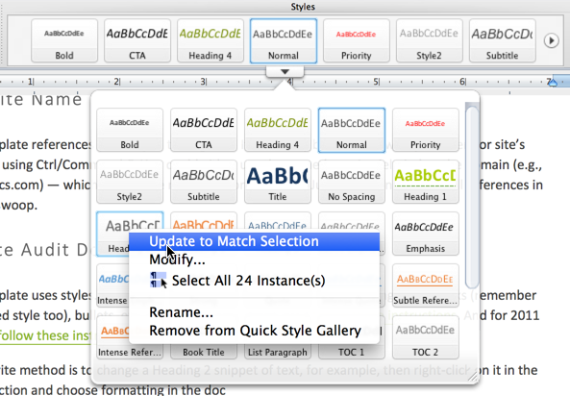

Data Pull for Audit
Take these steps to prepare your data for the audit:
1. Purchase a Screaming Frog license if you don’t already own a license. (You can crawl up to 500 URLs with its free version.) This tool is, aside from your analytics tool, the most important tool you’ll use in a site audit, in my opinion.
2. Set up the Screaming Frog configuration (Configuration > Spider) to match your crawling needs. Here are the options I use most:
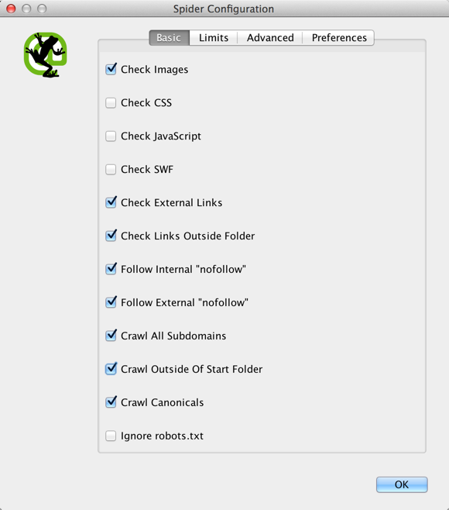
3. Choose from the following custom configurations you want to track in Screaming Frog (Configuration > Custom). Whatever you enter into one of the 10 filter fields will be searched and dropped into that particular category if Screaming Frog finds the code or text you enter. Some popular ones I use are categorized and listed below.

Tracking
Does Not Contain: analytics\.js – This identifies pages on your site that are missing your Google Analytics training code (if you’re using Universal Analytics). Alternatively, you could use your account/view ID (e.g., 'UA-15381183-3').
Does Not Contain: <iframe src="//www.googletagmanager.com/ – If you’re using Google Tag Manager (GTM), this snippet will identify pages missing your GTM tag.

Structured Markup
Why use markup? Read this post to learn about the importance of schema.org markup in SEO and this one to understand the importance of using markup on your site to aid in social performance.
Contains: itemtype="http://schema\.org/ – This snippet checks for the presence of schema.org markup on your site.
Contains: prefix="og: http://ogp\.me/ns#" – This snippet checks for the presence of Facebook Open Graph markup.
Contains: twitter:card – This snippet checks for the presence of Twitter card markup.
Contains: xmlns: – This snippet checks for RDFa
Contains: vcard – This snippet checks for vcard markup
Contains: hreview – This snippet checks for hreview markup

Note: For Pinterest and Google+ microdata, you can use Open Graph or schema.org markup.

Miscellaneous
Contains: name=fragment – This snippet checks for the presence of AJAX on the page.

More
You can find a comprehensive list of markup here.

Prepare Data File
Create an Excel file that you call audit-data.xlsx. If you choose a different name copy/replace this file name with your file name or Google Sheets file name to replace it throughout the doc in one fell swoop.

Create Google Spreadsheet with Breakdown of Issues
When I’m finished the audit, I list all of the issues in a Google Spreadsheet that I share with the client. You can use mine as a template (http://bit.ly/audit-action-items).
To create your own copy, while logged in, go to File > Make a copy. Please don’t request access. I filter out these requests from my email because I receive so many. Just delete audit items that aren’t applicable by right-clicking on the row number and choosing Delete row.
You’ll want to customize the header row with your branded colors (step 1 below), as well as the border color (steps 2 – 4 below).
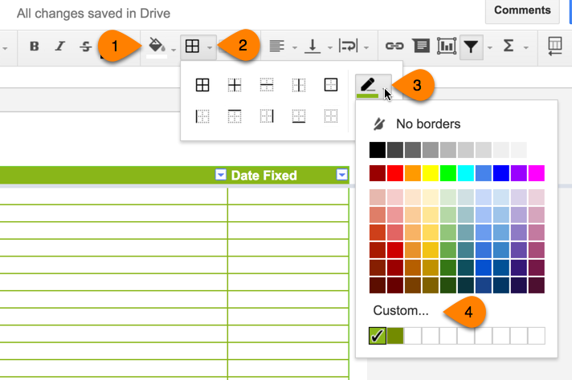
Pro Tip: If all you have are the RGB colors for your branded colors, you can use this tool to convert them to hex values. And if you don’t know your branded colors, you can use the Color Picker in the Web Developer Toolbar (under the Miscellaneous tab) to find your site’s branded colors.
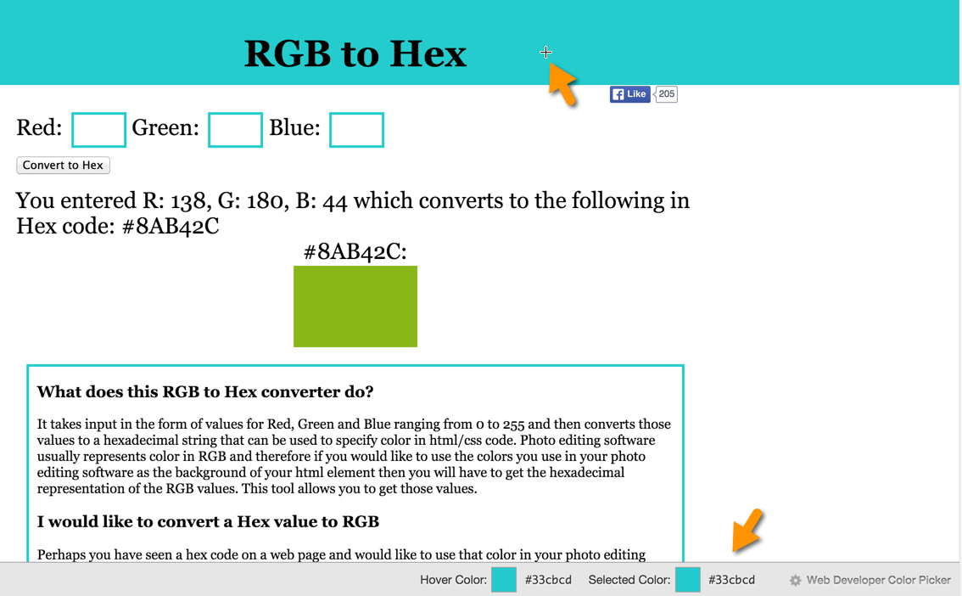

Audit Tools
The list below is a sampling of the tools I reference throughout the audit.

Google Analytics (Required)
Or whatever you use to measure analytics.

Google Webmaster Tools (Required)
This is essential. If you don’t have an account, you can sign up here. It’s free.

Bing Webmaster Tools (Required)
Bing also has its own webmaster tools. Their Index Explorer report (under Reports & Data) is the best tool on the market for assessing site architecture. It’s worth the effort of setting it up on your site just for that report.

Mozbar (Required)
The Mozbar offers a ton of functionality you can use for site audits, as well as a plethora of other marketing tasks. You can check out my seven marketing uses I’ve identified for the Mozbar in this post. It’s one of my fave SEO tools. And it’s free.

Web Developer Toolbar (Required)
The Web Developer Toolbar is a must-have in any developer or marketer’s treasure trove of tools. You can download it for Chrome (my preference) or Firefox.

ahrefs (Required)
Even the free version of ahrefs.com gives you a ton of insight into SEO performance.

Moz (Optional)
Moz has a number of reports that all assist with site audits. Its Open Site Explorer is my tool du jour for backlink research, but there are also other really good ones, like Majestic, ahrefs, and SEMRush.

Reverse Internet (Optional)
Reverse Internet is a good (and free) tool to use to find out subdomains a site uses, as well as affiliate sites (IOW, sites using the same AdSense account.

SEMRush (Optional)
SEMRush is one of my favorite tools for SEO on the market. Among many other things, it lists the keywords your site ranks on the first two pages of Google for. (You can also choose Bing if you receive a significant amount of traffic from Bing.)

SEO Site Tools (Optional)
The SEO Site Tools Chrome extension is very useful when performing site audits.

Barracuda’s Panguin Tool (Optional)
The Panguin Tool creates an overlay of Google’s updates on top of your Google Analytics data. I’m still super bummed about losing Chartelligence. It was amazing. But the Panguin Tool is a decent proxy.

IIS SEO Toolkit (Optional)
The IIS SEO Toolkit is chock full of valuable insights when you’re analyzing your site’s performance.

Supermetrics (Optional)
Supermetrics offers a plugin for Excel and Google Sheets. It’s second to none for quickly pulling your Google Analytics data using the API into Google Sheets. You can also use it to pull Facebook, Moz, AdWords, and SEMRush data, to name a few.

EXECUTIVE SUMMARY
Detailed here is a 100-foot view of the issues identified in the [CLIENT] site with some priority values.
To easily navigate back to the Executive Summary, if you follow any of the links to pages deeper in this document, simply press Ctrl-G (Mac: Command-Option-G) and enter 13 to navigate back to the Executive Summary (which normally falls on page 13).
I sometimes provide links to reports from Google Analytics and/or Webmaster Tools, so it would be a good idea to log in to these in your default browser (in other words, the one that Word automatically opens when you click a link from a Word document). If you have a personal or other professional Gmail/Google Apps login, you may want to log out of it in your default browser and use a secondary browser.
I provide the chart below as a quick view of the issues detected with your site. The implementation priority is specified in ascending order, with 1 being the most important recommendation on down.
[DIRECTIONS] When you’re finished the audit, go back through and fill out if the recommendations in each section require content and/or technical support and assign priorities. I then take the final list of recommendations and publish them to the aforementioned Google Spreadsheet with a column for the date each task was completed.
Recommendations | Content Support | Technical Support | Priority
Content | Yes | Yes
Crawl | No | Yes
Sitemap | No | Yes
Robots.txt | No | Yes
Canonicalization | No | Yes
Architecture | No | Yes
Internal Links | No | Yes
Inbound Links | No | Yes
Semantic Markup | No | Yes
Images | No | Yes
Video | Yes | Yes
Titles | Yes | Yes
Meta Descriptions | Yes | Yes
Site Speed | No | Yes
Analytics | No | Yes

BREAKDOWN OF ISSUES

1.0 Content
Content Issues
Implementation Priority
Content Support | Yes
Technical Support | Yes

Since the beginning, search engines have sought to serve up pages that searchers like and engage with, without immediately returning to the search results page to try again. Taken in aggregate over millions of queries a day, search engines build up a good pool of data to judge the quality of their results. Google, in particular, uses data from Chrome, its toolbar, and Android devices to measure these engagement metrics. It’s, therefore, essential that each page on the site includes relevant, unique, and fresh content that is strategically optimized to rank for a site’s targeted keywords.

1.1 Issues

Site contains “thin” pages
[INVESTIGATE]
Look in Screaming Frog: Internal > Word Count > reorder (by clicking on the column header) to show URLs with the lowest word counts at the top. Then select the Export button next to the Filter button.
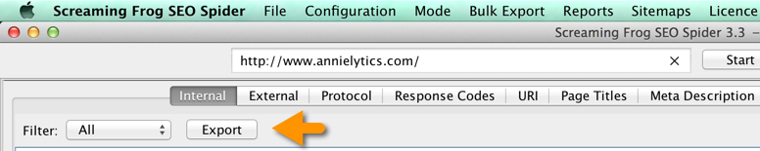
Pro Tip: First sort the Word Count column in ascending order. Look at the first page with a 200 status code. Open that page by right-clicking on the URL in the Address column and selecting Open in Browser. Count the number of words of actual content, then subtract that number from the word count SCREAMING FROG is reporting when you export this report and bring it into Excel or Google Sheets. That’s how many words the template accounts for. Each page should have that amount deducted from the word count SCREAMING FROG reports to evaluate thin content.
Also, use Barracuda’s Panguin Tool to see if the site has been impacted by any of Google’s Panda updates, which take aim at issues like thin content.
[/INVESTIGATE]

Pages with content duplicated on other pages
[INVESTIGATE]
To find duplication on external sites, get snippets of content from key pages and search Google for them in quotation marks. Look for duplication internally and externally.
If the site has been scraped, report it to Google and Bing.
[/INVESTIGATE]
To find duplication internally, choose the URI tab in Screaming Frog, and choose Duplicate from the filter.
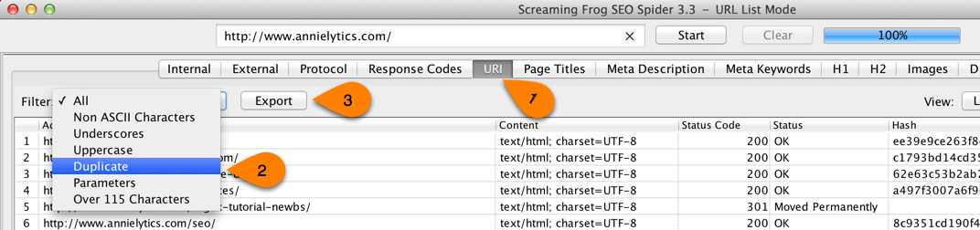

Alternatively, you can export the report from the Internal tab and then use conditional formatting in Excel to identify duplicate hashes (basically the equivalent of a social security number for content).
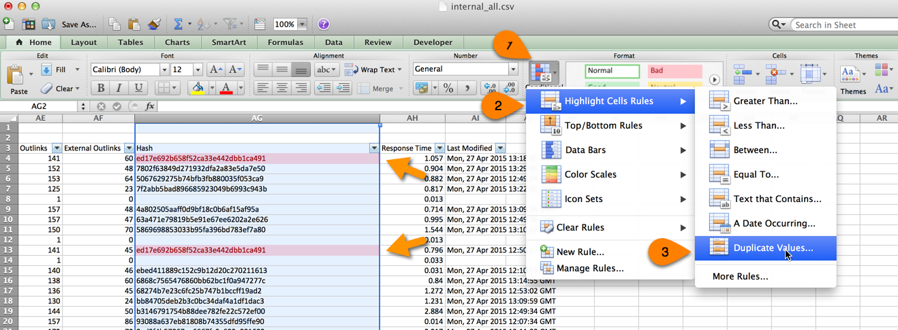

You can sort the Hash column in ascending order in Excel using table formatting or a filter to cluster duplicate hashes.
[/INVESTIGATE]

Under-optimized pages
Sometimes, in our haste to populate our sites with content, pages can be under-optimized for the keyword(s) you want them to rank for. One unintended consequence of this is keyword cannibalization. This occurs when you have multiple pages optimized for the same keyword, and the search engines can’t determine which page they should send searchers to for that keyword.
A great way to find examples of this kind of cannibalization is to go to the Search Analytics report in GWT (under Search Traffic) > select the Queries group by clicking the radio button > click a keyword to create a filter > select Pages by clicking its radio button. This will show you if you have multiple landing pages competing for this term. Go to these pages and see how you can dial up the optimization on the pages you want to rank and deoptimize the pages you don’t want to rank.
Pro Tip: If you find multiple pages competing for the same term, you might want to filter by Devices (i.e., Desktop, Mobile, Tablet) and/or Search Type (i.e., Web, Image, Video) to narrow down where the cannibalization is occurring.

Pages with missing H1 tags
[INVESTIGATE]
Screaming Frog: H1 > Filter: Missing > Export.
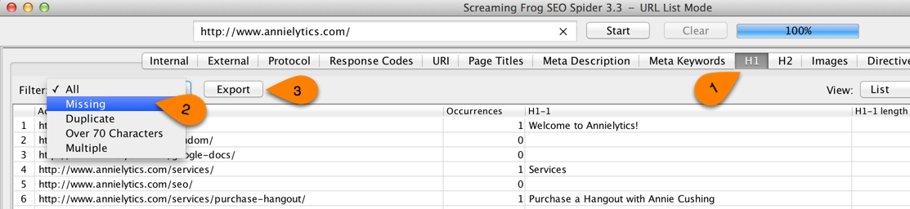
If there are more than a handful of URLs, create a tab in the audit-data.xlsx file. But first look at the URLs that are missing H1s. Do this by right-clicking on the URL under Address and choosing Open in Browser. Are there any patterns? For example, are all category pages missing H1s? Are they using H2s for page titles instead of the H1? If so, let them know that Google puts slightly greater weight on the H1 tag over the H2 and use it to determine what the page is about, but I would mark an observation like this as low priority.
To easily see the heading tags on a page that you click through to, use the Web Developer Toolbar: Outline > Outline Headings.
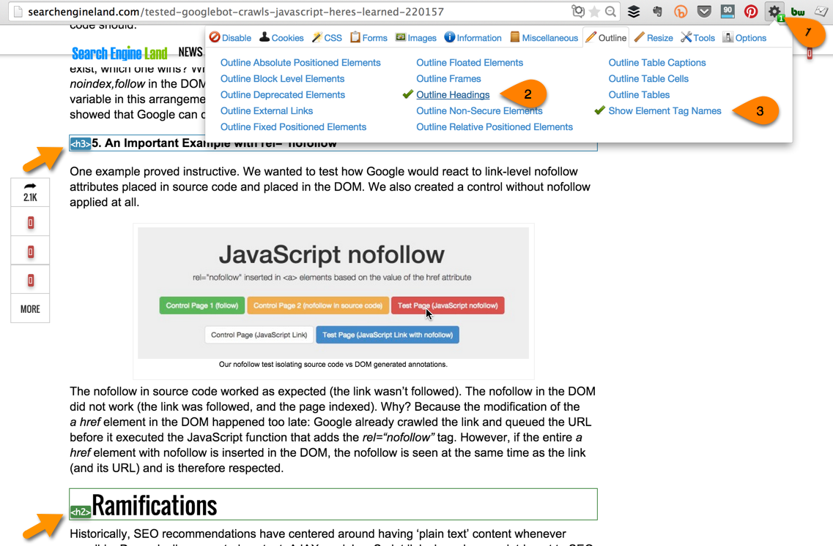
[/INVESTIGATE]
Search engines use the H1 tag to interpret what a page is about, much the same way readers of a magazine use article titles to get an idea of what an article is about. When pages are missing H1 tags, it’s harder for both visitors and search engines to decipher what the page is about. The H1 tag should contain a judicious use of the keyword(s) you’re targeting the page for. Be careful to make the language natural and not keyword stuffed. If you have to decide between user experience and SEO, go with user experience.

Top pages have low click through rates
[INVESTIGATE]
Use the Search Analytics report in GWT (under Search Traffic) to analyze look for pages with high impressions and/or clicks but low CTR. You can sort the table by a new metric by clicking on its heading.
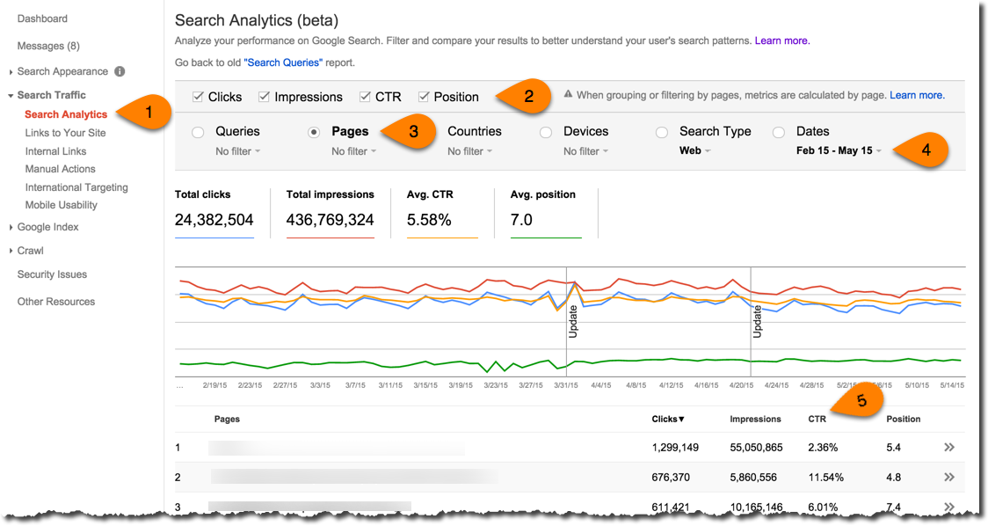
You can learn more about how to rock the Search Analytics report in this video tutorial I did as an alpha tester.
[/INVESTIGATE]

Landing pages are under-optimized
[INVESTIGATE]
Look at the site’s top-performing pages (or its money pages if the client provides you with a list of these pages) and look at metrics like bounce rate. In Google Analytics make sure you use the Landing Page dimension and not the Page dimension.
If you’re not comfortable with creating custom reports in Google Analytics, check out this video tutorial I did.
[/INVESTIGATE]

Pages contain multiple H1s
[INVESTIGATE]
Screaming Frog: H1 > Filter: Multiple > Export.
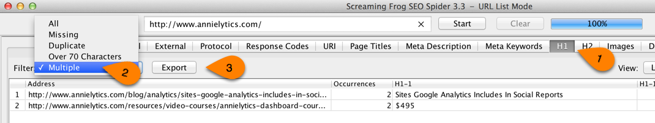
If the site you’re auditing doesn’t have missing H1s but does contain multiple H1s, use the template text from the Missing H1 section and modify it for multiple H1s.
Also, you’ll notice below, there’s a link to another section of the audit. Always be looking for opportunities to link to other sections of the audit. You can add these links by following these steps:
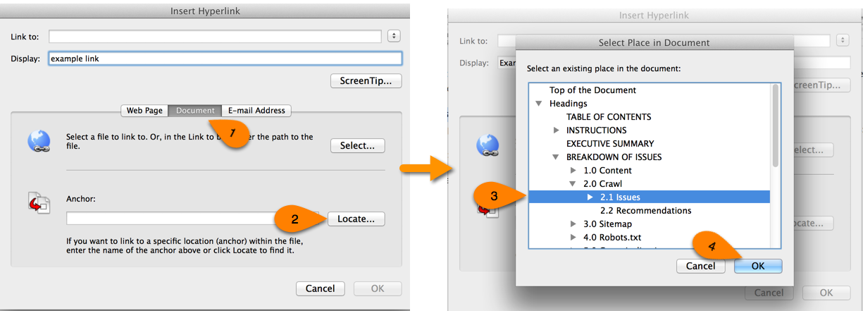
In Word for PC, you just press Ctrl-K. Next, choose Place in This Document from left sidebar, then choose the appropriate section.
Another helpful tip is to click on the Address heading to alphabetize the URLs. This will group URLs from the same directories to help you find patterns.
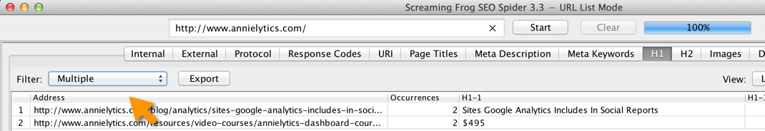
[/INVESTIGATE]
Following the newspaper/magazine analogy in the Missing H1 section. It tells a reader what your page is about. You wouldn’t have two titles on a newspaper or magazine article. In the same way, a web page should only contain one H1.

Site contains obtrusive ads
[INVESTIGATE] Look to see if there are too many ads above the fold, offensive ads, ads to competitors, etc.

1.2 Recommendations
- Recommendation 1
- Recommendation 2
- Recommendation 3

2.0 Crawl
Crawl Issues
Implementation Priority
Content Support | No
Technical Support | Yes
Search engines frequently crawl websites in order to determine which ones should be indexed in their massive databases. Search engine crawlers — also known as robots or spiders — collect pages they deem high quality.
Over time, search engines will continue to request previously downloaded pages to check for content updates. A certain amount of bandwidth is then allocated for the periodic reviews based on the pages’ calculated relevancy. Every time a page is downloaded, bandwidth is used, and once a website’s allocated bandwidth limit is reached, no more pages will be crawled until the next review. This is referred to as a site’s crawl budget, and it works just like any other budget. But in the case of a search engine, when your site’s crawl budget has been exhausted, the bot moves one.
Since there is a limited amount of allotted bandwidth, it is crucial to direct the crawlers to the content you want to be included in the search engine’s index of web content and eliminate any unnecessary or duplicate content. Your site’s crème de la crème, if you will.
To use your site’s crawl budget effectively, it’s important to investigate errors reported in Google Webmaster Tools to make sure that those pages render properly. If a page can’t be fixed, due diligence must be applied to make sure the page doesn’t negatively impact the rest of the site. This can be done several ways:
- 301 redirect these pages to their new URLs. Use a 302 if the redirect is truly temporary (e.g., a product that’s out of stock).
- If you have a lot of missing pages, allow them to return a 4xx (e.g., 404, 410) status code but remove these pages from your XML sitemap(s).
- Remove any internal links pointing to these error pages.
- If any of your 4xx pages have received significant traffic or links, you need to make sure you 301 redirect these pages.

2.1 Issues

Dips in crawl rate
[INVESTIGATE]
Look at the crawl rate in GWT: Crawl > Crawl Stats.
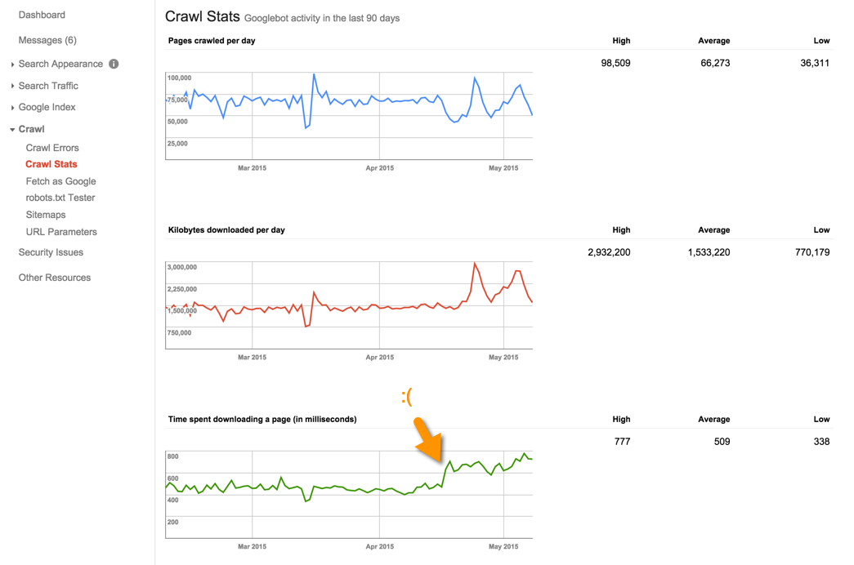
Oftentimes, there’s a correlation between the time spent downloading a page and the pages crawled per day. It makes sense. The less time it takes googlebot to crawl your pages, the more pages it can get to before your site’s crawl budget runs out.
Also, look at avg page load time in GA for the past three months (Behavior > Site Speed > Page Timings) to see if there were spikes in average site speed during periods of reduced crawl rate.
[/INVESTIGATE]

Index bloat
[INVESTIGATE]
GWT Indexed Pages
Go to the Index Status report in GWT: Google Index > Index Status to see how many pages were indexed in the last crawl (hover over the last point to see the number of pages indexed).
You can get more details by clicking the Advanced tab:
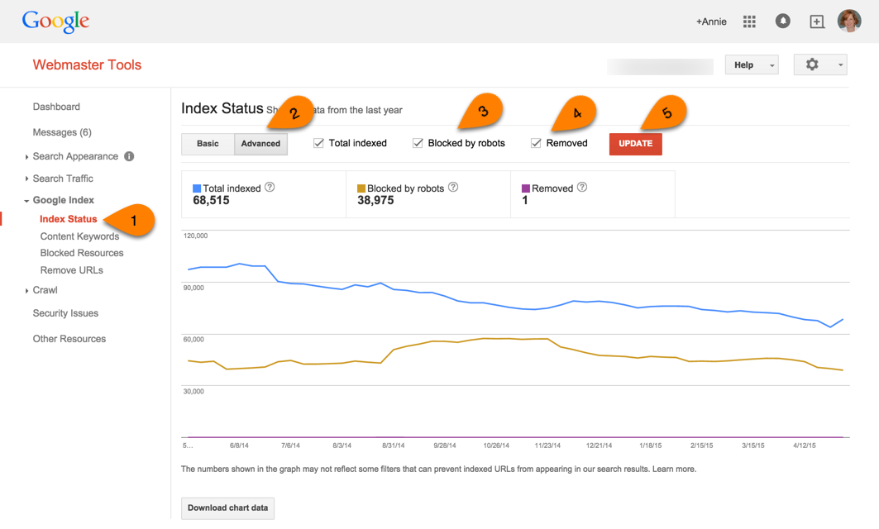
Bing Indexed Pages
Dashboard > Site Activity > Pages Indexed / This Period
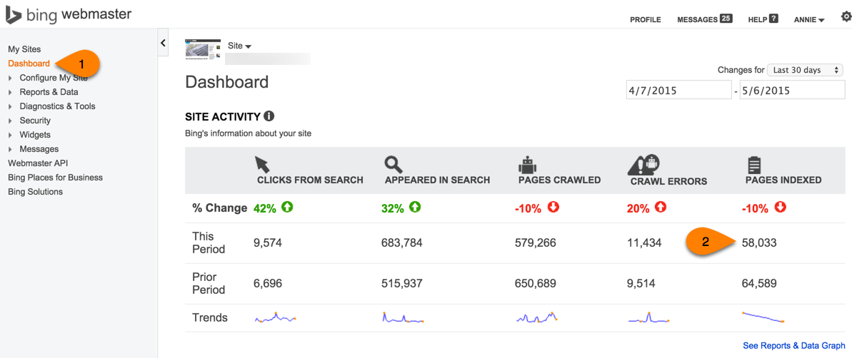
If you don’t have access to BWT for the client, just enter site:domain.com (no www) into Bing.com to get the number of indexed pages.
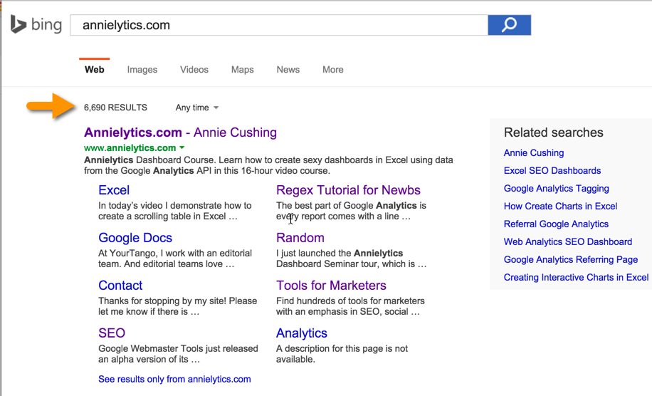
Google Analytics
Pull up the Organic Landing Pages report: Acquisition > All Traffic > Channels > Click on Organic Search > Change Primary Dimension to Landing Page. (See in this post why I recommend getting to the Organic Landing Pages report this way over Acquisition > Campaigns > Organic Keywords > Change Primary Dimension to Landing Page in this post. (Spoiler alert: This report is subject to sampling, which is the kiss of death to large sites. The Channels route is a hack I discovered that avoids sampling.)
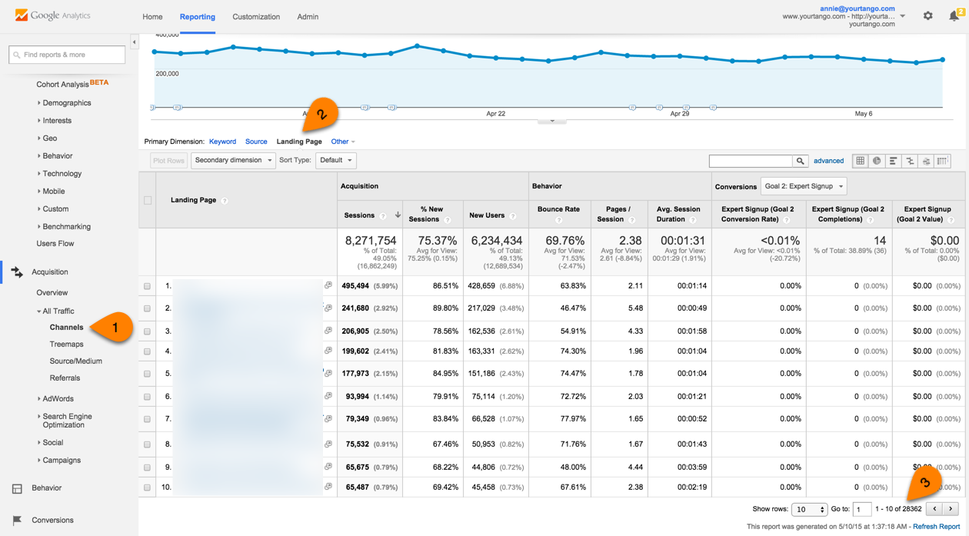
Look at the number of landing pages receiving organic traffic for the same date range you have selected in Google Webmaster Tools. You can see this number in the bottom-right corner of the page after you apply the filter above (3 in the screenshot above).
Filter your Organic Landing Pages report to see how many pages have received at least 10 sessions (formerly known as visits).
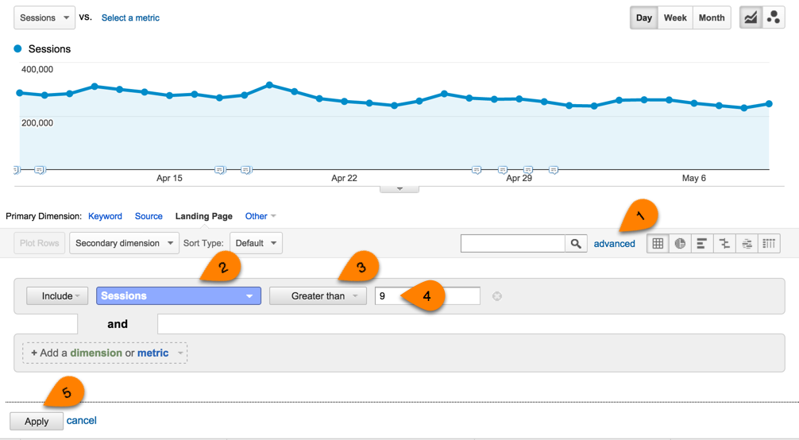
Fill in these numbers below …
[/INVESTIGATE]
According to Google Webmaster Tools, the [CLIENT] site currently has [NUMBER OF PAGES] pages in Google’s index [LINK TO REPORT].
Yet only [NUMBER OF PAGES] landing pages received organic traffic last month [LINK TO REPORT]. That means that about [FRACTION] of [CLIENT]’s indexed pages are receiving any traffic, and most of those pages just received one visit in the past month. Only [NUMBER OF PAGES] landing pages received at least 10 visits.
In a perfect world, every page that Google indexes it will find valuable enough to send organic traffic to. We don’t live in a perfect world, and most sites will never achieve a 1:1 ratio, but we’d like to get your site as close to a 1:1 ratio as possible.
Bing is not nearly as efficient, however. It’s crawled [NUMBER OF CRAWLED PAGES – FOUND IN BWT DASHBOARD] this month and indexed [NUMBER OF INDEXED PAGES]. You can view the report [LINK TO REPORT].
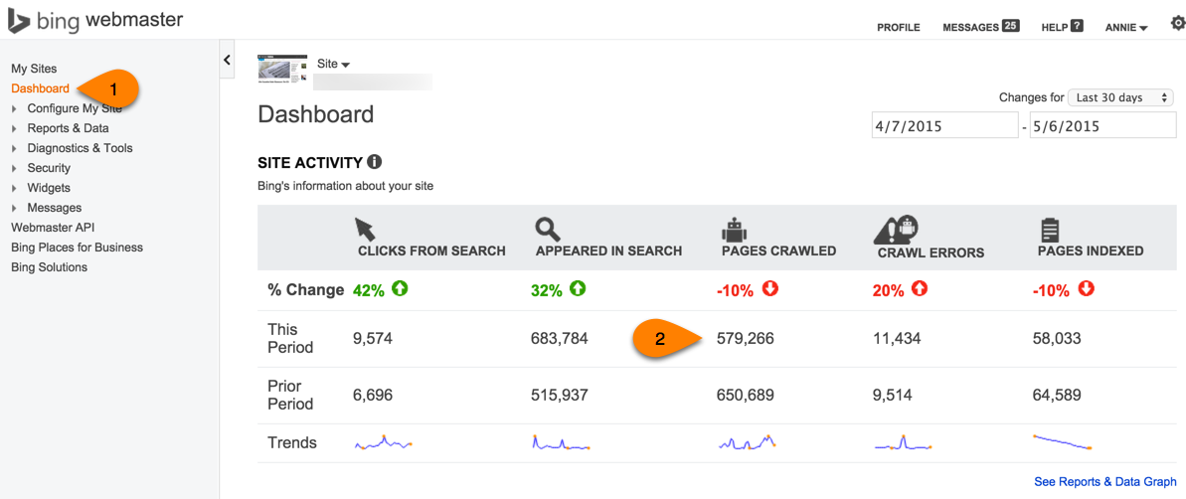

Important pages are broken
Broken pages, when configured properly, return a 404 (or 410) status code. Not all 404 pages are bad. Sometimes pages are removed, and there really aren’t good pages to redirect them to. Google and Bing understand that and will eventually remove pages returning a 404 from their indices. What [CLIENT] doesn’t want is for the search engines to remove important pages from their indices. Examples of important pages that are those that have attracted quality links, garnered traffic, and/or driven conversions.
The Important 404 Pages tab of the audit-data.xlsx workbook includes the important URLs. I looked at web traffic from the past three months for this analysis. These are the most important pages to either restore or 301 redirect to appropriate pages (preferably not the [CLIENT] homepage).
[INVESTIGATE] This analysis gets a little complicated. Follow the instructions in the Steps to Find Valuable 404s workbook (Directions are on the Directions tab. Clever, right?)

No custom 404 page
One way to rope visitors back in to the site that have landed on a broken page is to serve up a custom 404 page. A good custom 404 page will help people find the information they're looking for, as well as provide other helpful content and encourage them to explore your site further. For information on configuring your server to display your new 404 page, check your server or web host’s documentation.
Here are some suggestions Google has offered for creating an effective 404 page that can help keep visitors on your site and help them find the information they're looking for:
In order to prevent 404 pages from being indexed by Google and other search engines, make sure that your webserver returns an actual 404 HTTP status code when a missing page is requested.
Tell visitors clearly that the page they're looking for can't be found. Use language that is friendly and inviting.
Include 404 in the page title, so you can easily track these pages in Google Analytics (or whatever analytics service you’re using).
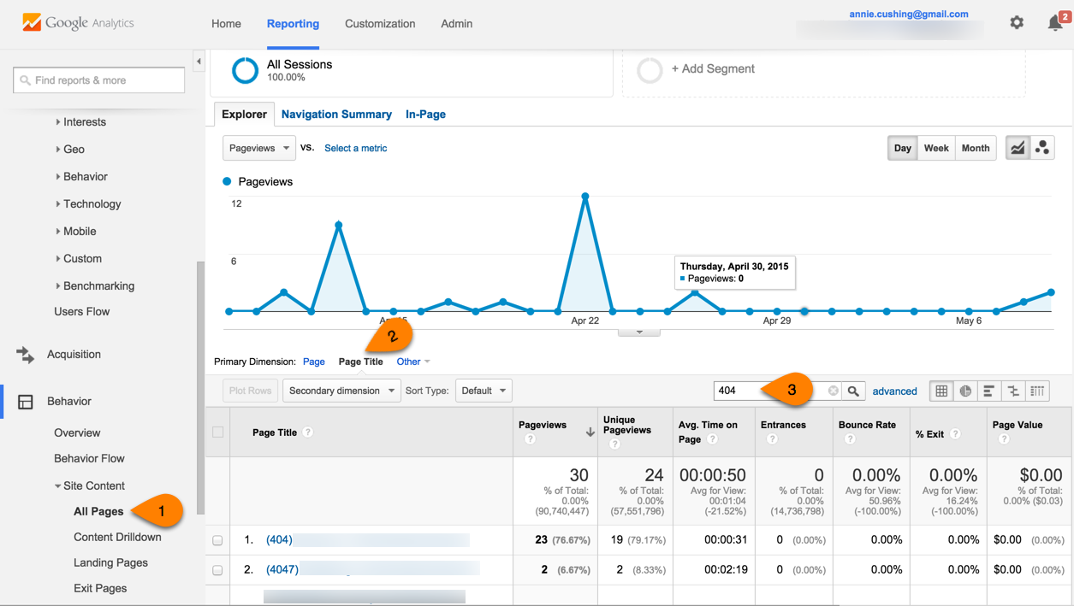
Add links to your most popular articles or posts, as well as a link to your site's homepage.
Have a site search box somewhere on your custom 404 page. (More sophisticated visitors tend to search; less advanced visitors tend to browse.)
Consider providing a way for users to report a broken link.

404 pages are trending upward
[INVESTIGATE] GWT: Crawl > Crawl Errors > URL Errors > Not found
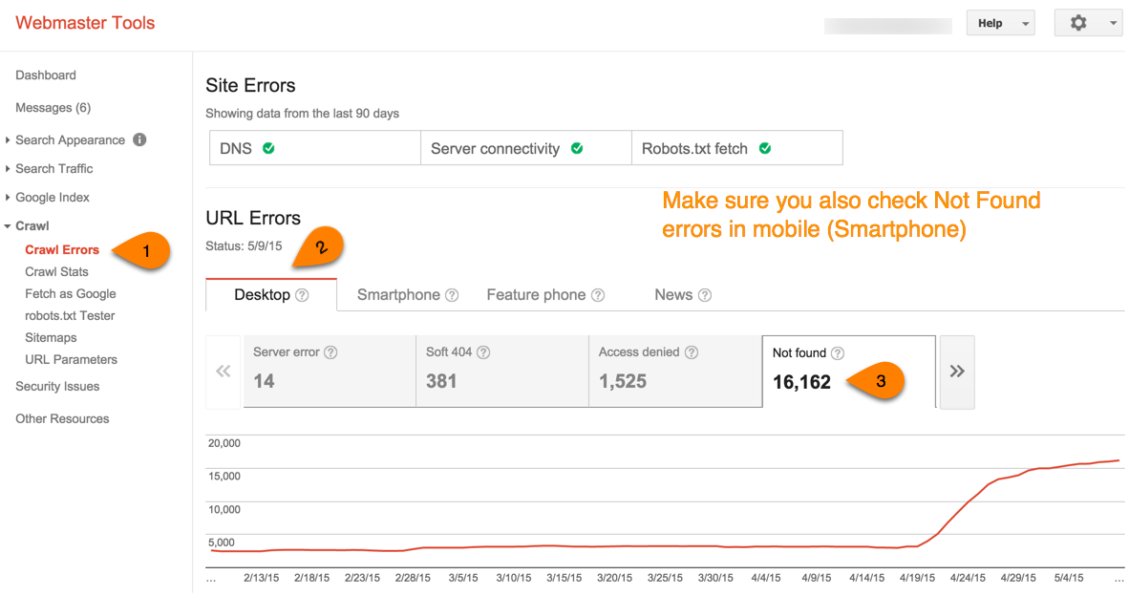

404 pages aren’t configured properly
[INVESTIGATE] GWT: Crawl > Crawl Errors > URL Errors > Soft 404s. Soft 404s are 404 pages that show up found pages. IOW, they return a 200 status code instead of a 404 status code. Sometimes they’ll also 302 redirect (or even 301 redirect) to a dedicated 404 page. If you want to see the individual redirects or grab a screenshot for the client, enter the errant URL into www.urivalet.com.
To see an example of what a soft 404 looks like in URI Valet, check out this monster screenshot.

Site pages are returning server errors
[INVESTIGATE] GWT: Crawl > Crawl Errors > URL Errors > Server error

Server denies search engines access to URLs
[INVESTIGATE] GWT: Crawl > Crawl Errors > Site Errors > DNS / Server Connectivity

Server errors are trending upward
[INVESTIGATE] GWT: Crawl > Crawl Errors > Site Errors > DNS / Server Connectivity. Grab a screenshot of the DNS or Server Connectivity report if you see these errors trending up and to the right.

Site contains cloaked URLs
Cloaking is a server technique that some sites utilize to try to fool the search engines into awarding rankings a site doesn’t deserve. A site shows one version of a web page to users and a different version — many times overly optimized — to search engines. This is a stealth method that Google and the other search engines consider deceptive since it attempts to bias the spiders into ranking the web page for terms that should be out of reach. If detected, cloaking could cause your site to be penalized.
[INVESTIGATE]
Enter the site into Aaron Wall’s SEO Cloaking Checker.
Check for user agent cloaking by surfing the site as googlebot. You can do this in Chrome Developer Tools by taking the steps below:
- Right-click on the page and choose Inspect Element.
- Click the phone icon to enter Device Mode.
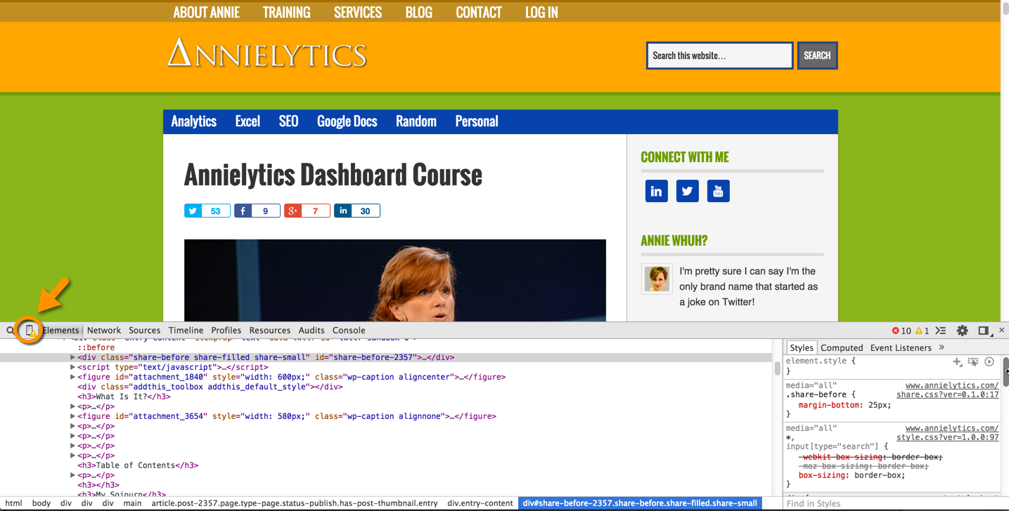
- Click the drawer icon to show the drawer.
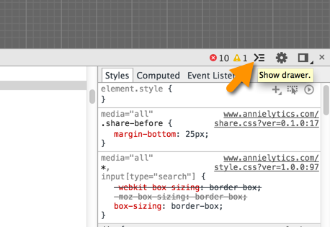
- Under the Emulation tab in the drawer, select Network and then set the user agent to Googlebot (or Googlebot Smartphone if you want to spoof that bot).
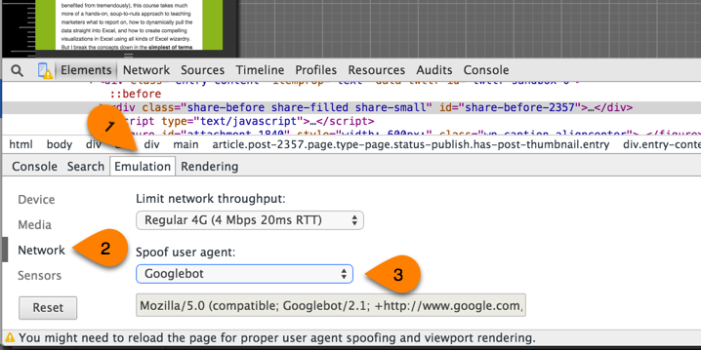

Check for IP-based cloaking by using Google Translate because many cloakers don’t bother to differentiate between the spider coming in for the purpose of translating or coming in for the purpose of crawling. And it uses the same range of Google IP addresses.

Site isn’t blocking blog category, tag, and archive pages
[INVESTIGATE]
Check a few of your site’s category and/or tag pages to see if they are indexed. The easiest way to check is to use the Mozbar.
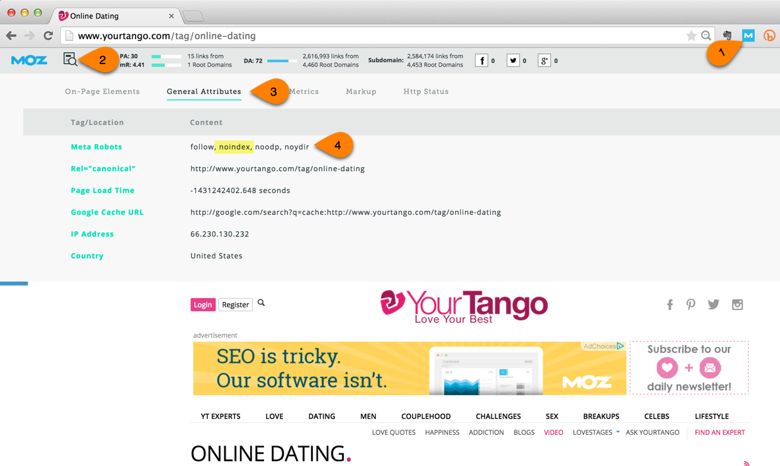
Also, check your analytics to see if you have organic traffic coming to these category and/or tag pages before noindexing them. If you do, do not set them to noindex. I’ve seen category and tag pages perform well for publisher sites especially.
To check for category/tag pages in Google Analytics, pull up your organic landing pages (Acquisition > All Traffic > Channels > Click on Organic Search > Change Primary Dimension to Landing Page) and use the following regex in the report filter:
Category pages with no trailing forward slash: ^/[a-zA-Z-_]+[^/]$ (screenshot)
Category pages with a trailing forward slash: ^/[a-zA-Z-_]+/$ (screenshot)

If your category/tag pages are in a directory (e.g., /tag/ or /category/, you would just add that to the regex: ^/category/[a-zA-Z-_]+[^/]$.
[INVESTIGATE]
These pages can create duplicate content for a site and provide minimal value in comparison to individual content pages. They can be made useful to both searchers and search engines by providing a paragraph or so of content pertinent to that particular category or tag. By adding some unique content to these pages, you can keep these pages open to search engines. However, in many cases, if you don’t take that extra step, you should block them from search engines by adding a noindex, follow tag to them.
Most content management systems provide the ability to set this in your backend. If not, they can be applied programmatically by way of URL pattern matching with the use of regular expressions.
The robots meta tag would go in the <head> section of the page and look like this on [WHATEVER PAGES SHOULD BE BLOCKED] pages:
<META NAME="ROBOTS" CONTENT="NOINDEX, FOLLOW">

Paginated URLs without the rel=”next” and rel=”prev” tags
[INVESTIGATE]
Sites frequently use paginated URLs for product category pages (e.g., /coats/womens/page=3) and article pages (e.g., /news/world/article-title/page=3). Various Googlers have recommended using the rel=”next” and rel=“prev” tag (technically attributes, not tags) to these pages.
Using the report filter in your Organic Landing Pages report, filter by your site’s pagination parameter (e.g., page=) to see if your site’s paginated content is getting organic traffic. If so, you could be cannibalizing your primary paginated page (which is what Google would usually prefer to send traffic to).
A few good tips for checking for paginated content:
The most common source of paginated content is search results pages. Do a site search and see how your site treats page 2+ of results.
Does the site publish articles that are broken into different pages?
In Screaming Frog, look at duplicate H1s for signs up pagination. Click the Address heading to sort the table alphabetically. This will cluster similar pages together, making duplicates easier to spot.
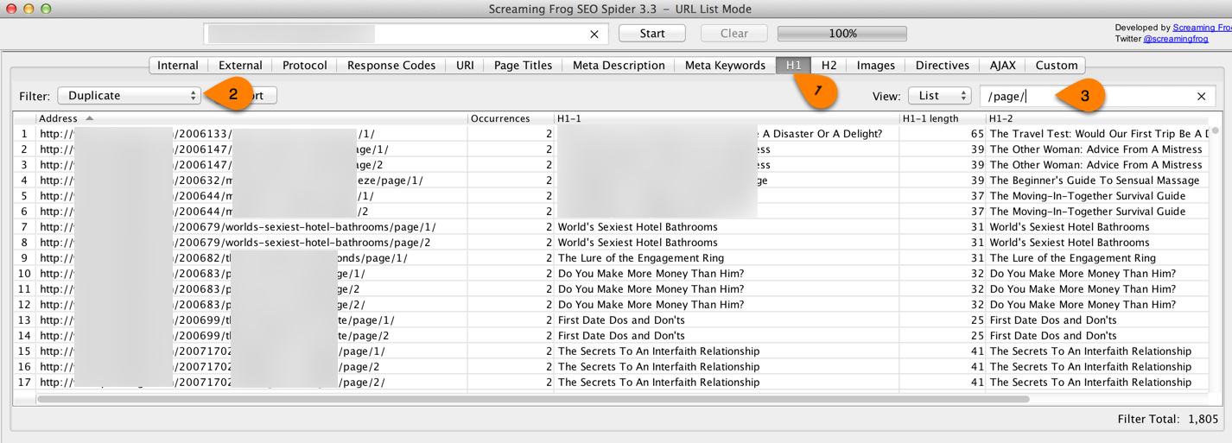
[/INVESTIGATE]
Pagination has always been a sticky problem for search engines. They can cause crawling inefficiencies and excessive duplicate content. They can also create problems with undesirable pages ranking for important terms, in cases where the search engines don’t pick your preferred URL.
Fundamentally, pagination is an interface problem. Long, scrolling pages can cause latency, which can, in turn, cause visitors to leave your site (or bounce). In an effort to remedy this issue, Google released some recommendations for how to resolve pagination issues in March 2012.
One of their solutions is to create a view all page and place a canonical tag on all the paginated content that points to the view all page. Most webmasters find this solution laughable since very few people (other than search engines that want to index as few pages as possible) want to view all running shoes, for example, on one page.
A more reasonable solution, Googlers posited, was to take advantage of the HTML 4/5 link element rel=”next” and rel=”prev”. This creates a chain of references that tells the search engines when they see page 3 of a string of paginated content, “Page 2 is the previous page, and Page 4 is the next page.”
You can learn more about how to resolve pagination issues from the Google site for developers. The Search Engine Land site also has an excellent post on this topic.

Site uses nofollow tags ineffectively
[INVESTIGATE] Look in Screaming Frog to see if the site is using nofollow tags (under Directives).
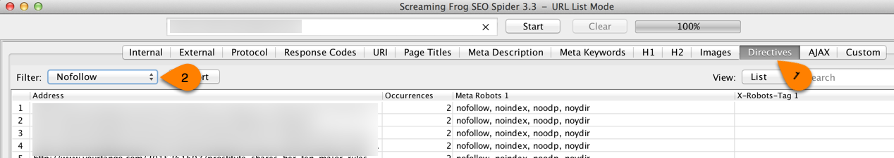
Back in 2008 PageRank sculpting was all the rage. Site owners were littering their site with nofollow tags to try to funnel all of their site’s authority to their money pages. You’ll still find artifacts of this craze in older, optimized sites. When you do, you can officially say …


Navigation uses JavaScript
[INVESTIGATE]
Turn off JavaScript with Web Developer Toolbar and see if the navigation is still functional.
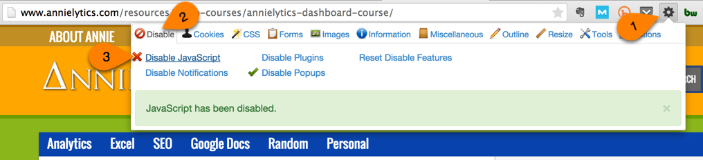
Also, check a few key navigation pages to make sure they’re cached. The easiest way to do that is with the Mozbar.
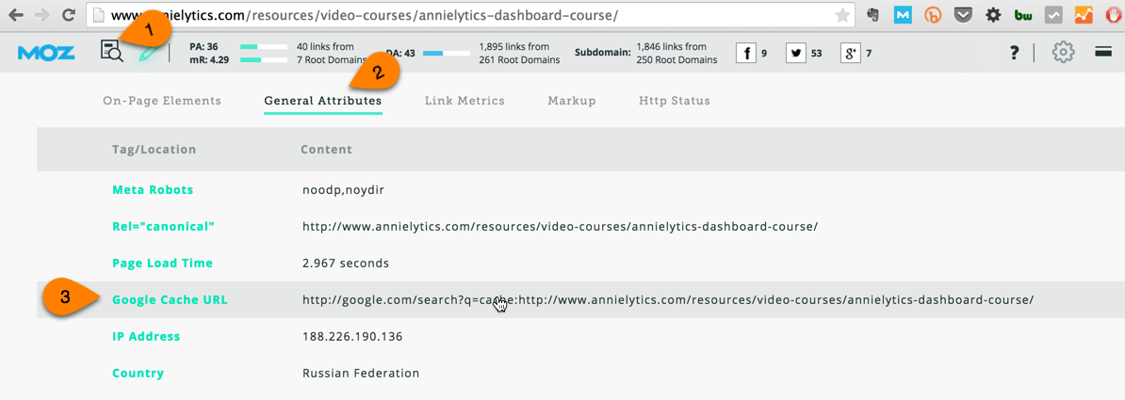
When you click on the URL highlighted in the screenshot above, you’ll see something like this if the page has been visited recently:
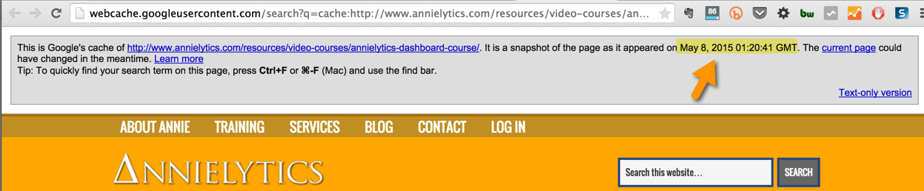
[/INVESTIGATE]
Navigation bars that use JavaScript are outdated and not in the best interest of users, search engines, or (ultimately) site owners. It’s much preferable to use CSS over JavaScript.

Secure site isn’t tracking properly
[INVESTIGATE]
Is the site set to a secure server?
If so, is the GA profile set to secure? Admin > View Settings > Website’s URL: https.
Also, is their GWT set to the secure site? Check the URL of the GWT account.
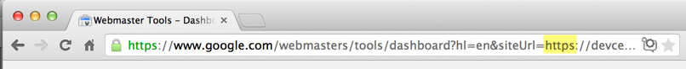
Finally, the Search Analytics report in Google Webmaster Tools (under Search Traffic) will be under-reporting if the site uses a combination of secure and non-secure URLs.
[/INVESTIGATE]

2.2 Recommendations
- Recommendation 1
- Recommendation 2
- Recommendation 3

3.0 Sitemap
Sitemap Issues
Implementation Priority
Content Support | No
Technical Support | Yes

XML sitemaps are designed to help search engines discover and index your site’s most valuable pages. Think of these pages as a site’s crème de la crème content.
The sitemap consists of an XML file that lists all the URLs of the site that you want to compete in organic search. This XML file also contains ancillary information, such as when a page has been updated, its update frequency, and relative importance.
Google recommends creating separate sitemaps for different types of content: images, videos, and text, for example. Then it’s important to update them each time new content is published with a multi-format XML sitemap, image, or video XML sitemap.
It’s important to update the sitemap only with the original versions of the URLs. They should not redirect or return errors. In other words, every page in the sitemap should return a 200 status code. Anything other than a 200 status code is regarded by the search engines as “dirt” in a sitemap. Duane Forrester with Bing said that Bing only tolerates a 1% of dirt in a sitemap. When asked what qualified as dirt, he replied, “Anything that doesn’t return a 200 status code.”
Finally, you should upload these sitemaps to Google and Bing’s webmaster tools. Google will tell you how many of the submitted URLs have been submitted and how many of those have been indexed, whereas Bing just tells you how many URLs were submitted.

3.1 Issues

No XML Sitemap for the site
[INVESTIGATE] Go to www.clientsite.com/sitemap.xml. If you don’t find one there, check Google Webmaster Tools (Crawl > Sitemaps) to see if either a sitemap, multiple sitemaps, or a sitemap index. You can also do a site: search in Google for sitemap, e.g., [ sitemap site:mysite.com]

Sitemaps not submitted to Google or Bing
[INVESTIGATE]
GWT: Crawl > Sitemaps // BWT: Configure My Site > Sitemaps
Google does a pretty good job at finding a site’s content; however, Bing is much more dependent on XML sitemaps for discovery. Not submitting your XML sitemap(s) to the search engines — especially Bing — is like leaving money on the table.
[/INVESTIGATE]

Missing specialty sitemaps
[INVESTIGATE] Do they have all sitemaps they should? Web, mobile, image, video, news?

Errors in XML sitemap
[INVESTIGATE] Check this sitemap validator for errors and list them in the audit.

Non-200 pages in sitemap
[INVESTIGATE]
Run sitemap through Screaming Frog: Mode > List > Upload List button > From a File > File Format: SiteMap.
After crawling the sitemap, select the Response Codes tab and look for status codes that don’t = 200. You can also use the report filter to just look at 3xx, 4xx, or 5xx codes. Alternatively, you can sort by response code to group them (have all the 200s together, the 300s together, etc.) by clicking the Status Code header in Screaming Frog.
To export, you can either export the whole dataset and filter in Excel or use the filter and export the filtered list. I usually just export the whole thing and remove the all but the problem URLs, then add them to the audit-data.xlsx file.
[/INVESTIGATE]

Non-canonical URLs in sitemap
[INVESTIGATE]
Screaming Frog: Directives > Filter: Canonicalised. This filter gives you all of the URLs in the sitemap that have canonical tags that aren’t self-referencing. All URLs in a sitemap should be the canonical version. Remember: You are telling the search engines: These are my favorite pages that I want searchers to find. Search engines don’t want junk in that trunk.
I used this method to discover why Google was only indexing 5% of one client’s sitemap. Most of the URLs had canonical tags that pointed to other URLs, which communicates to the search engines, “I know we’re telling you these are our most important pages because we put them in the sitemap, but they’re not REALLY our most important pages because they all have canonical tags that point to OTHER pages.” The search engines’ response to that:

[/INVESTIGATE]

PPC pages in sitemap
[INVESTIGATE] Look to see if there are PPC pages in the sitemap. Check for campaign parameters in like s_kwcid, ppc, and cpc.

Blocked pages in sitemap
[INVESTIGATE]
Look to see if there are noindex tags on pages in the sitemap. Also, look at the robots.txt file to see if any pages in your sitemap would be blocked.
To check for noindex pages in Screaming Frog, filter by noindex in the Directives tab. To check for URLs that are blocked by robots.txt you have to kind of eyeball it. I use advanced filters in Excel, but the learning curve is a bit high for how to use them. If you want to become an advanced filtering badass (they’re actually more powerful than regular expressions, if you can imagine that), you can read my post on Search Engine Land for how to rock them. And if you don’t know what regular expressions are, you need to read this post I wrote that simplifies how to understand them and use them in Google Analytics.
[/INVESTIGATE]

Orphaned pages in sitemap
[INVESTIGATE]
Look to see if there are pages in the sitemap that didn’t show up in the Screaming Frog crawl.
Steps to compare the two lists (with a screenshot that explains everything):
- Import XML sitemap into Excel (PC only). If on a Mac, run the sitemap through Screaming Frog (Mode > List > Select File > Sitemap > Navigate to SML sitemap file), run the crawl, and export the list of URLs into an Excel document.
- Move the sitemap csv into the same Excel workbook as the Screaming Frog crawl (right-click on tab at bottom of worksheet > Move > Select SCREAMING FROG workbook > choose where you want to move it).
- In the cell next to the first URL from the sitemap, enter this formula: =IF(ISNA(MATCH(B2,'SCREAMING FROG Crawl'!A:A,0)),"Orphan","OK"). Modify it to fit in your sheet name and data ranges.
[/INVESTIGATE]

Sitemap too large
[INVESTIGATE] Open the sitemap in Chrome and search the page (Ctrl/Command-F) for http. This will show you the number of both http and https URLs in the sitemap. Look in the upper-right corner of the browser.

Sitemap inadequately organized
One great way to monitor indexation rates by category is to create a different sitemap for each major category of the site and a sitemap index that contains all of these category sitemaps. So [CLIENT] could potentially have a sitemap index that contains the following sitemaps:
- Category 1
- Category 2
- Category 3
The advantage to this approach is GWT’s Sitemaps report [LINK TO REPORT] actually breaks down how many URLs were submitted and indexed, as mentioned earlier. By breaking your sitemap into categories, you have the ability to identify which areas of the site are problematic. You could instantly find, for example, that [EXAMPLE CATEGORY] pages were indexed at a 95% rate, while [ANOTHER EXAMPLE CATEGORY] page were indexed at a 56% rate. This is data you can act on. AJ Kohn wrote a great blog post that explains this process more.
[INVESTIGATE]
AJ Kohn wrote a great post on optimizing sitemaps you can check out here.
[/INVESTIGATE]

3.2 Recommendations
Recommendation 1
Recommendation 2
Recommendation 3

4.0 Robots.txt
Robots.txt Issues
Implementation Priority
Content Support | No
Technical Support | Yes

The robots.txt file is a very important text file placed in a subdomain’s root directory. This file provides search engines directives regarding the crawling of the site, from blocking the crawling of specific pages or directories to the entire site.
Given the potential for disaster a robots.txt file carries, great care should be taken to ensure it follows the specifications laid out here. If you want to learn more about how to configure a robots.txt file, there was a great interactive guide published to the Moz site.
It’s not recommended to use robots.txt to prevent the indexing of site content that has quality inbound links pointing to it because, if the search engines can’t access a page, they can’t credit you for those links. Similarly, you shouldn’t use robots.txt to block a page that contains valuable links to other pages on your site. If the bots can’t access the page, they can’t follow links on that blocked page, which means authority will not be passed to those linked pages.
Even if you choose to not use the robots.txt file to prevent the crawling of any of the site pages, it’s still recommended to use the robots.txt to specify the location of the site’s sitemap.xml file, as specified in the sitemaps.org documentation. If the site uses multiple sitemaps, then the link should point to a sitemap index that includes links to all of the site’s sitemaps.

4.1 Issues

Missing Robots.txt file
[INVESTIGATE]
A site’s robots.txt file is very important. There should be a robots.txt file saved to the root of each subdomain. You can use the Hostname report (Audience > Technology > Network > Primary Dimension: Hostname) to discover all of the subdomains that are tagged with Google Analytics.
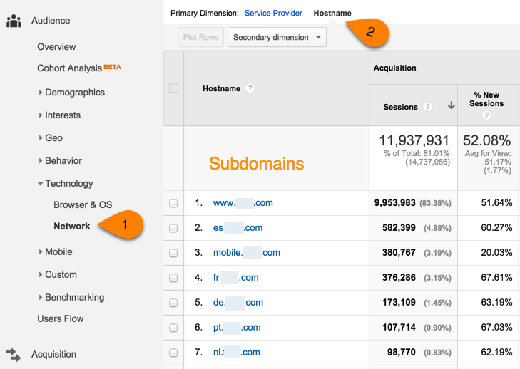
Of course, if you use different views, properties, or accounts, this report won’t help you identify all of your subdomains. In that case, Reverse Internet is a great tool I sometimes use to identify all of a site’s subdomains. Just search for the domain, then click the Subdomains tab. Here’s an example of what it looks like for heroku.com (a site I know has 80 bajillion subdomains):
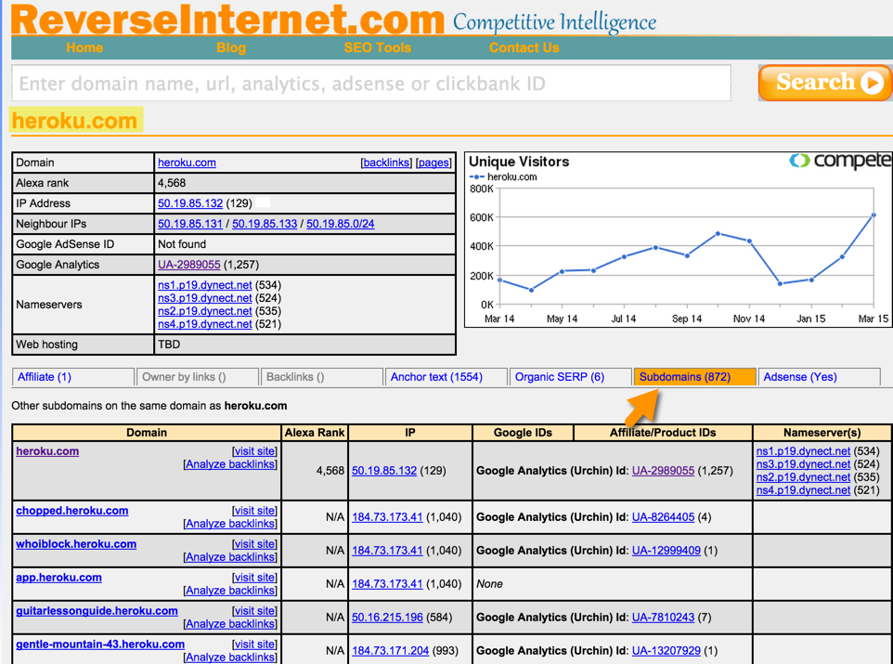
[/INVESTIGATE]

Pages missing from robots.txt
[INVESTIGATE]
Are there pages or directories that should be included in your robots.txt? Some line items I commonly see are:
Disallow: /cgi-bin/
Disallow: /tmp/
Disallow: /profile/
Disallow: /images/ (where /images is the directory for your template images)
Your site should also block cart and conversion pages. You can find your goal completion pages by navigating to Conversions > Goals > Goal URLs in Google Analytics. Find out the site’s ecommerce conversion pages by asking the webmaster.
I personally don’t recommend blocking login pages. Many customers get to their login page by searching for it in Google (e.g., bank of america login).
[/INVESTIGATE]

No Sitemaps XML declared in Robots.txt
The search engines have requested that site owners link to their sitemap(s) or sitemap index in their robots.txt file. The sitemap link(s) should be prepended with sitemap: as you can see in the screenshot below from the Moz site:
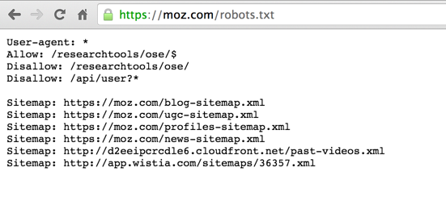

Blocked pages in Robots.txt that shouldn’t be blocked
[INVESTIGATE] Examples of this are your site’s CSS and JavaScript files. Matt Cutts made an appeal on behalf of Google in this video that webmasters not block CSS and JavaScript files from Google. Search Engine Land published an interesting study on Google’s crawling of JavaScript files, which you can read here.

Errors in Robots.txt
[INVESTIGATE] Run your site through Google’s robots.txt Tester tool (under Crawl in GWT).

4.2 Recommendations
Recommendation 1
Recommendation 2
Recommendation 3

5.0 Canonicalization
Canonicalization Issues
Implementation Priority
Content Support | No
Technical Support | Yes

In a perfect SEO world, the content on your site will only be accessible from one URL. This URL is referred to as the canonical URL. Reality is usually quite far from the ideal most SEOs strive for. That said, when canonical issues are scaled out to impact the site en masse, the site can really suffer. Imagine going into a horse race with the choice between one strong horse or several weaker horses. Which would you choose? The canonical version of a page of content is that strong, healthy horse.
To illustrate how subtle canonical issues can be, the following URLs may seem like they are the same page. But for a search engine these are actually different pages:
http://samplesite.com
http://www.samplesite.com
https://www.samplesite.com
http://samplesite.com/index.html
http://www.samplesite.com/index.html
https://www.samplesite.com/index.html
http://www.SampleSite.com/Index.html
http://www2.samplesite.com/
http://www.samplesite.com/?id=15423&src=bing+ad
Even though all of these URLs show the same content and refer to the same page, technically they’re all different.
This kind of duplication creates a host of issues for your site:
- Dilution of page authority caused by both internal and external inbound links pointing to several URL versions of the same page.
- Self-cannibalization in the search results pages, with different versions of the same page competing for the same queries.
- Inefficient crawling since search engines spend more time crawling the same content and leave less time to discover new content.
Because of these issues, the best solution is to 301 redirect non-canonical URLs to the canonical version of the page whenever possible. When a redirect isn’t feasible, the next best solution is to add a rel=”canonical” tag in each of the site pages, giving credit to its canonical URL.

5.1 Issues

Homepage not canonicalized properly
[INVESTIGATE]
Run your site through Open Site Explorer (or a similar tool). Majestic allows you to run verified sites for free, which you can read more about here.
Look at the external backlinks pointing to each version of the homepage and let client know that they could be consolidated. Here’s an example screenshot I gave a client of a pivot table showing the number of links to each version of the homepage. If you’re not comfortable with pivot tables, I did a video walkthrough in this post that includes both Mac and PC.
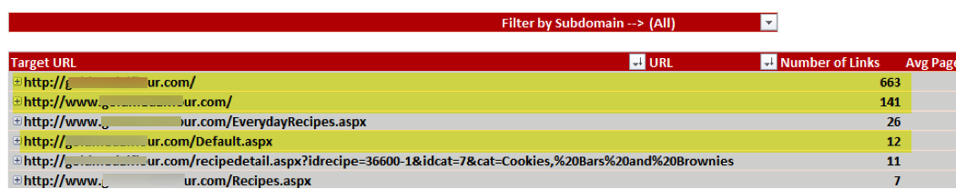
Another way to unearth canonical issues is via Google Analytics. Go to Behavior > Site Content > All Pages and change the primary dimension to Page Title. Click on the homepage title to drill down to the URI (a URL without the protocol and hostname) to see if there are multiple URLs receiving significant traffic for the same title from different URLs. (I tend to ignore URLs with low sessions.)
I also spot canonical issues when I sort the Screaming Frog’s Internal tab alphabetically by Address (by clicking on the heading). When I see them, I’ll scroll to the right until I get to the Canonical Link Element 1 column. If the URL has a canonical link that points to the canonical version of the homepage, I’ll give it a pass, but I prefer redirecting non-canonical pages because I’d rather not put myself at the mercy of search engines to honor my canonical tags. That said, as an auditor, you want to avoid the urge to become too pedantic in your audit recommendations because clients (or your boss!) don’t want to waste time and resources (read money) fixing “issues” that may not impact the bottom line.
If non-canonical pages are redirecting (yay!) make sure they’re using a 301 and not a 302 redirect (boo!).
[/INVESTIGATE]
Non-canonical versions of your homepage should be 301 redirected to the canonical version of the homepage. At minimum, a canonical link element (also informally referred to as a canonical tag) should be placed on the homepage so that duplicate versions will point back to it. It would look like this:
<link rel="canonical" href="http://www.yoursite.com" />
This element should go in the <head> section of the page.
Also, a self-referencing canonical element should go on every page of the site to shore up its canonical pages from duplicate URLs. Query parameters can be added to URLs (like when someone shares a page from your site using Buffer), and sometimes these parameter pages can get indexed by Google. You want to protect your site from this happening:


Non-www & /index.html versions of the URLs not 301-redirected
[INVESTIGATE]
See notes in previous point. Screaming Frog’s Page Titles tab can provide valuable insight into this research as well. Filter by Duplicate as shown below.
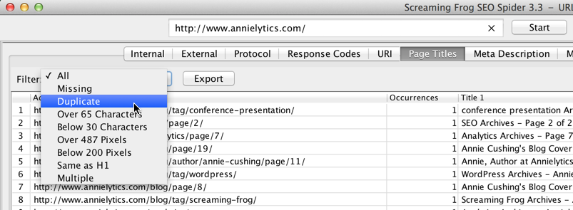
Also, check to make sure your site’s logo, Home navigation link, and breadcrumb point to the canonical version of the homepage URL.
[/INVESTIGATE]

URLs can be accessed through both secure and non-secure protocols
[INVESTIGATE]
Your site shouldn’t ever show two versions of the page — at least not in a perfect world where unicorns roam freely. Do a search in Screaming Frog for https and test a few pages to see if the secure version of the URL redirects to the non-secure (or vice versa if your site is intended to be secure).
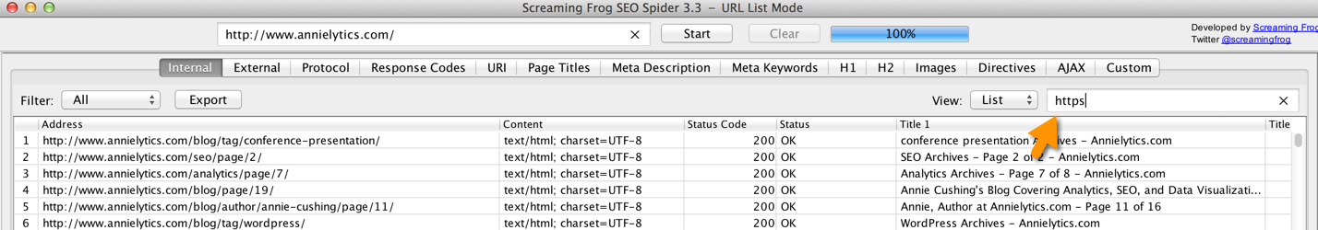
[/INVESTIGATE]

URLs don’t resolve to a single case
[INVESTIGATE] I test putting capital letters in both the domain and the page path. Sometimes a site is configured to redirect to lowercase for the domain only.
To avoid duplicate content caused by URLs with different cases, you should configure your site to redirect URLs to lowercase. This is the best way to preserve page authority.

Trailing slashes creating duplicate content
[INVESTIGATE] Look in Screaming Frog or Google Analytics for duplicate pages as already described in the audit template.

Parameter URLs creating duplicate content
[INVESTIGATE]
Query parameters can wreck a site with wasted crawl budget (at best) and duplicate content (at worst). Many SEOs I respect posit that it’s enough to use canonical tags to protect from duplicate content. And that does protect your site from duplicate content, but sites with many query parameters (like ecommerce sites) can literally make search engines crawl millions of duplicate pages because of all of the permutations possible from their query parameters.
To identify these problematic parameters, I first check out GWT’s URL Parameters report (under Crawl).
Look at this partial list for an ecommerce site:
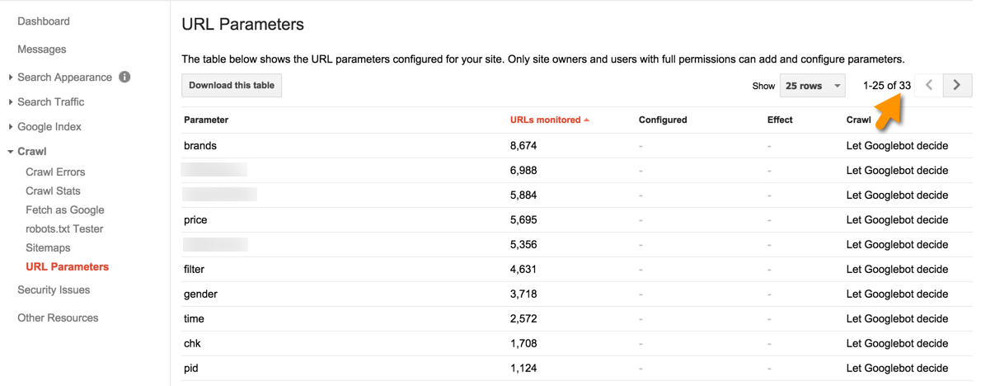
Imagine all the different possible combinations of these parameters. These can quickly cause a condition I refer to as index bloat. You can learn more about this issue by going to slide 7 of this presentation I did for SearchLove.
One ecommerce site I worked with had 5.8 million pages indexed by Google (cf: slide 9) but only had 37k pages receiving at least one visit from organic search, and only (brace yourself) 645 actually drove any revenue for that same period. So only .6% of their indexed pages were driving any organic traffic, and a meager .01% generated any revenue (see slide 13).

I realize marketers are scared to death of the robots.txt file because of the potential to raze a site with it. But the way I got their crawl budget under control (Google literally had thousands of versions of a single page in their index) was by adding query parameters that didn’t establish unique content to their robots.txt file.
The logic I followed was: “Does this parameter create unique content (like you’d see with the “page” parameter on some sites)?” If it didn’t, I’d block it by just adding it to the robots.txt file.
So let’s say you have an ecommerce site that sells clothing. And the site has a page for men’s funny t-shirts, with a URL looks like: http://www.mysite.com/tshirts/funny/men/. If that’s the page you want to compete in search but your site offers faceted navigation that allows visitors to filter results by things like size and color and a sort by price or relevancy option, steps should be taken to keep these pages out of the search engines’ indices. To wit, if people wouldn’t search for men’s funny t-shirts green or men’s funny t-shirts low to high price, you wouldn’t want your page with funny t-shirts filtered by color or your sorted page to compete in the search engines.
So one way to prevent this from happening would be to add those query parameters to your robots.txt file like so:
Disallow: /* sort=
Disallow: /*color=
Disallow: /*size=
Like I said, many marketers would recommend just putting a canonical tag or noindex tag on these duplicate pages. If your site only uses a handful of query parameters, no harm no foul. But if you have a larger ecommerce site that uses many different query parameters, your site’s crawl budget is going to be wasted on search bots crawling hundreds or thousands of the same page that you (and your visitors) don’t care about. These robots.txt line items save your crawl budget, as well as save your site from index bloat.
[/INVESTIGATE]

Canonical tag not included on the site pages
[INVESTIGATE] Addressed above. At minimum, all pages you want to compete in organic search should have self-referencing canonical tags.

IP doesn’t canonicalize
A site’s IP address should resolve to the same URL. If it doesn’t, search engines may be unsure as to which URL is the correct one to index.
[INVESTIGATE]
Run your site through SEO SiteCheckup, then search for “IP Canonicalization Test” on the results page to hop to this report.
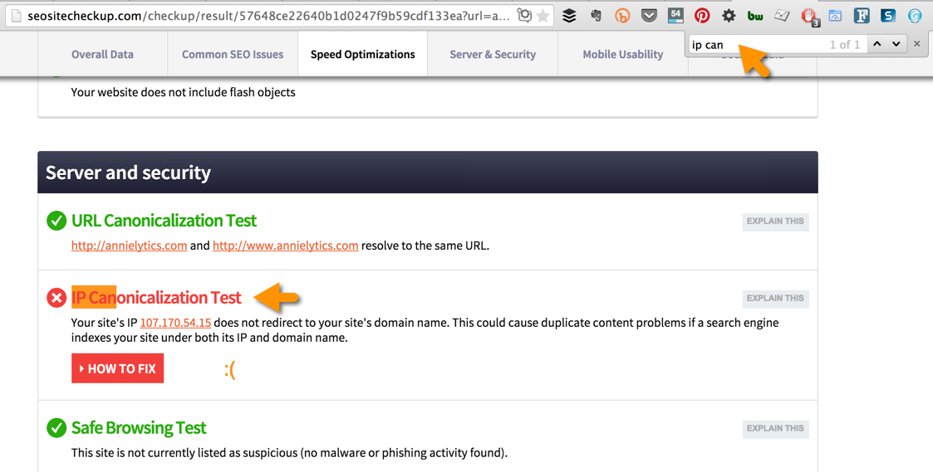
[/INVESTIGATE]

Site doesn’t canonicalize print pages
[INVESTIGATE] Look to see if your site is using CSS for print pages or unique URLs. If you’re using unique URLs, these should be either be blocked (via the robots.txt file or a noindex tag) or canonicaled to the main, public-facing page by including canonical tags on these pages.

Conversion pages indexed
[INVESTIGATE]
Conversion — or thank you — pages should be noindexed. If they are indexed and start receiving organic traffic, your site’s conversion metrics will be messed up. I see this a LOT. To see if they’re indexed, either do a site: search for the URL (site:www.annielytics.com/thank-you/) in Google or check to see if the page has been cached. I demonstrate how to do that in the Navigation uses JavaScript section of the audit.
[/INVESTIGATE]

Other canonical issues
[INVESTIGATE] Check to make sure canonical tags that reference a page other than the one it lives on make sense. As mentioned earlier in the audit template, you can use Screaming Frog’s Directives report. Just filter by Canonicalised. (Those Brits and their silly uses of the letter “s” … Did I say that?) Seriously, scan these canonicals to make sure nothing funky monkey is going on under the boardwalk.

5.2 Recommendations
Recommendation 1
Recommendation 2
Recommendation 3

6.0 Architecture
Architecture Issues
Implementation Priority
Content Support | No
Technical Support | Yes

A good site URL structure should align itself with several best practices:
- Group topics together into category and sub-category pages to help both visitors and search engines to maintain topical relevance. Think of how a library is organized.
- Reflect the site’s organization through levels of directories and subdirectories. If you have the misfortune of a totally flat architecture (i.e., all pages saved in the root), you’ll need to get creative in how you send signals to search engines that certain pages are related. This can be accomplished, for example, by using breadcrumbs or adding a link to the category on the page, as Bustle has done to compensate for its less-than-optimal URL structure.
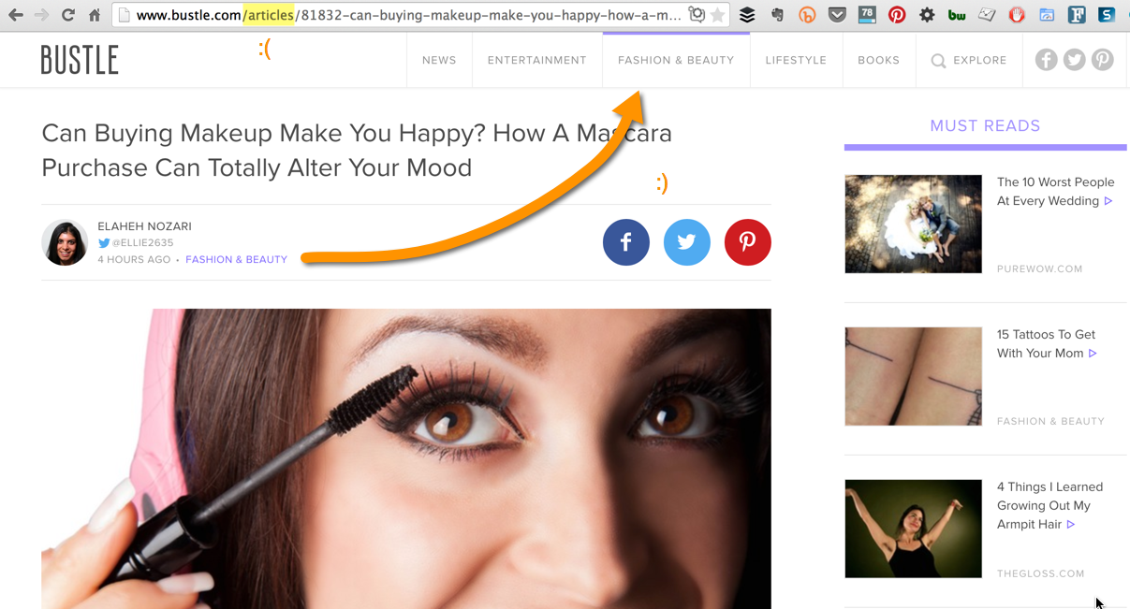
- Use only lowercase to avoid confusion with users and search engines.
- Use dashes (-) to separate keywords in the URL. Underscores also get the job done; they’re just the equivalent of decorating your yard with tires. (I kid! Sort of ….)

6.1 Issues

Issues with directory structure
[INVESTIGATE]
Use Bing Webmaster Tool’s Index Explorer report (under Reports & Data) to analyze site. It is, hands down, the best tool to analyze a site’s architecture. Look to see if it makes sense. You can also see how many links point to each directory, which is just fantastic.
The next best tool is Google Analytics’ Content Drilldown report (Behavior > Site Content > Content Drilldown). You start with the pages and directories saved to the root and can drill down it subdirectories to see pages and subdirectories in each directory (also called a category). Make sure you have a healthy date range selected to ensure you’re seeing a representative sample of your site’s traffic since this report is more dependent on visitors actually visiting your pages, unlike Bing’s Index Explorer report.
I am very hesitant to recommend overhauling a site’s architecture. A well-organized site is good for visitors and search engines. Sites flattened their architectures because search engines used to have a more difficult time getting to deep-linked pages. That’s no longer an issue for most search bots — and certainly not for Google ever since its Caffeine update in 2010. Migrations can be fraught with issues that can wreak havoc on a site. I basically only recommend them if I know the site has a really competent SEO on staff or retainer who can help them migrate with minimal impact to their search efforts. As mentioned earlier, you can overcome lack of architecture with breadcrumbs and inner linking.
But this issue can impact other areas of a site’s marketing efforts beyond search. For example, I worked with a publisher that relies heavily on display for its revenue. Because they had a URL structure similar to Bustle’s (shown above), as opposed to Cosmopolitan’s sublime structure, it was more difficult to bolster their ad-targeting efforts. If they would have had a better structure, they could have married it with their second- and third-party data to say, “If a visitor is a single millennial (what they get from second- and third-party data) and visits a page in our /dating/ category, show him/her an ad from our advertiser, eHarmony.”
So, believe it or not, there are other marketing considerations to weigh when doing a site audit. Revolutionary idea, I know. :)
[/INVESTIGATE]
Context is a ranking factor that can elevate your website past others competing for similar or related keywords, build topical domain authority, and increase conversions by having a higher number of pages occupying a larger percentage of market share for related keywords and queries. The architecture (and internal links) communicate context from page to page. The better structured this is, the better it is for users and search engines.
The Content Drilldown report in Google Analytics [LINK TO REPORT] provides a good overview of a site’s architecture. In a perfect world, a site will only have five to ten line items in this report because, like a library, your site should have top categories that spill into sub-categories, which spill into sub-sub-categories. This is one way to consolidate topical relevance.
The [CLIENT] site has [NUMBER OF LINE ITEMS] line items in this report, meaning that the site has lots of content saved in the root directory. A lot of these are also caused by query parameters, which can be cleaned up. You can read a blog post on how to do that here.
But a lot of these are just pages outside a directory and all dumped into the root. This hurts the site in search because search engines are dependent on a site’s structure to decide between things like sending a searcher to an article/product page (for longer-tailed queries that searchers tend to run further into the sales cycle) or a category page (for head terms that searchers tend to use earlier in the sales cycle, for example).

Non-hierarchically organized URLs
[INVESTIGATE] Whenever possible, a site should follow a tight organization. It’s not that different from principles of outlining you [should have] learned in your middle school English class.

Site has separate mobile pages
[INVESTIGATE]
Look at the site’s mobile traffic (Audience > Mobile > Overview). Compare user experience (using metrics like bounce rate, page/session, and average session duration), as well as results (using metrics like goal completions, transactions, and revenue).
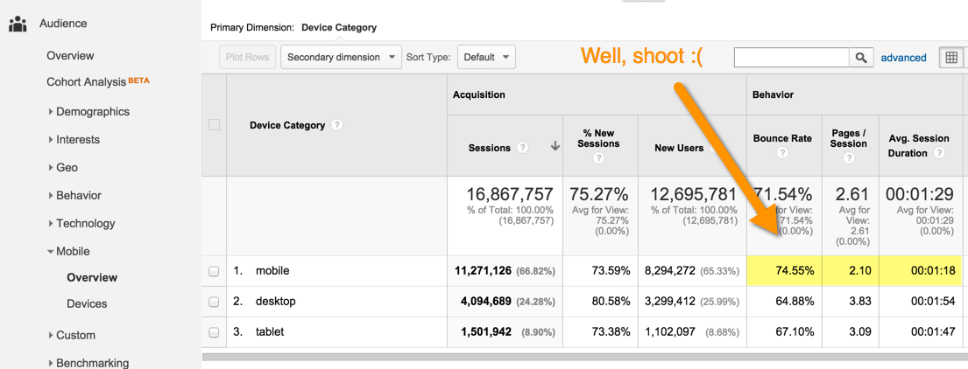
Consider recommending responsive design. Just make sure you recommend how the site can shave off page load time too since going responsive can add lag time.
[/INVESTIGATE]
You can read more about mobile issues in the Mobile section of the audit.

Breadcrumb links aren’t well organized
[INVESTIGATE] Do the breadcrumbs follow the logic of the site's architecture? Are they pointing to canonical versions of URLs?

Infinite scroll pages aren’t SEO friendly
[INVESTIGATE]
To make sure that search engines can crawl individual items linked from an infinite scroll page, make sure that you or your content management system produces a paginated series (component pages) to go along with your infinite scroll.
Learn more about Google’s recommendations here. BuiltVisible also published a great post on how to make infinite scroll pages search friendly.
[/INVESTIGATE]

Site uses an excessive number of dynamic URLs
[INVESTIGATE]
Search for an “=” in organic landing pages (Acquisition > All Traffic > Channels, then click on Organic Search and change the primary dimension to Landing Page).
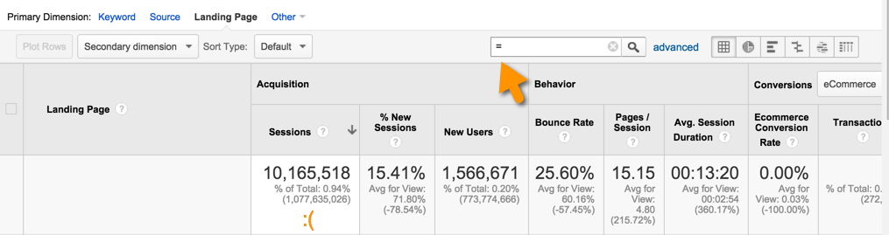

[/INVESTIGATE]

Non-descriptive URLs
[INVESTIGATE] URLs should use permalinks over parameter-driven URLs.

Broken links throughout the site
[INVESTIGATE] Look at the External tab of Screaming Frog. Identify pages with links that have a status code of 4xx or 5xx.

6.2 Recommendations
Recommendation 1
Recommendation 2
Recommendation 3

7.0 Internal Links
Internal Link Issues
Implementation Priority
Content Support | No
Technical Support | Yes
[INVESTIGATE]
A few good reports you can use for this analysis include:
Screaming Frog’s Redirect Chains report (under the Reports menu). This report is useful to see where your site has daisy-chain URLs, which can waste a ton of crawl budget.
GWT’s Internal Links report (under Search Traffic). Look at the URLs in your site that receive the most internal links. Then compare this report to your Links to Your Site report (also under Search Traffic) and/or your inbound links report from Moz, Majestic, ahrefs, SEMRush, etc. I think of it this way: My site’s outbound links tell me which pages others think are coolest on my site; internal links tell me which pages I think are coolest. Who do you think you should trust more? At minimum, you should try to funnel more authority to your money pages to bolster them with as much firepower as possible to compete in organic search.
Moz’s Open Site Explorer report filtered to only look at internal links.
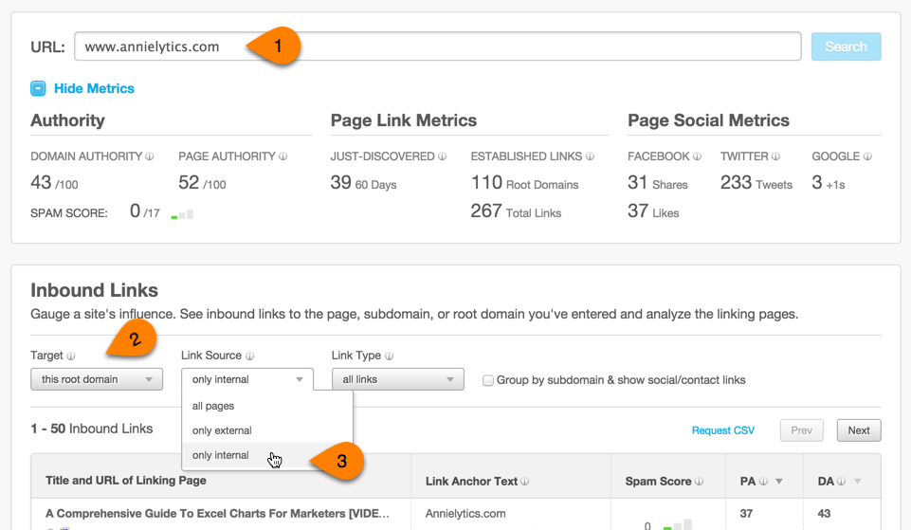
[/INVESTIGATE]
Internal links are not only used by visitors to browse through the site but also by search engines to discover content and pass authority to other internal pages.
To increase crawl efficiency and ensure that authority flows naturally from category pages down through the rest of the site and back up to the category pages, a few measures should be taken:
Link directly to the canonical URL. By linking to non-canonical URLs, you’re wasting your precious crawl budget by sending search engine spiders on a scavenger hunt to discover content you want indexed by search engines.
Use relevant, descriptive anchor text in the links without being unnecessarily repetitive or spammy.
Only use nofollow when linking to pages that you don’t really want to authority to (like the privacy policy page or your RSS feed, for example). Beyond that, keep the use of nofollow for internal links to a minimum. Overusing nofollow tags can be a red flag that the site has been manipulated to gain a competitive advantage in the search engines, something the search engines don’t like to see. You want your site to look virginal from an SEO standpoint as much as possible so that you don’t inadvertently find yourself on Google’s radar or tangled up in an over-optimization filter.

7.1 Issues

Site doesn’t link to pages with highest authority
[INVESTIGATE]
Step 1: Run Top Pages report from Open Site Explorer and download the CSV:
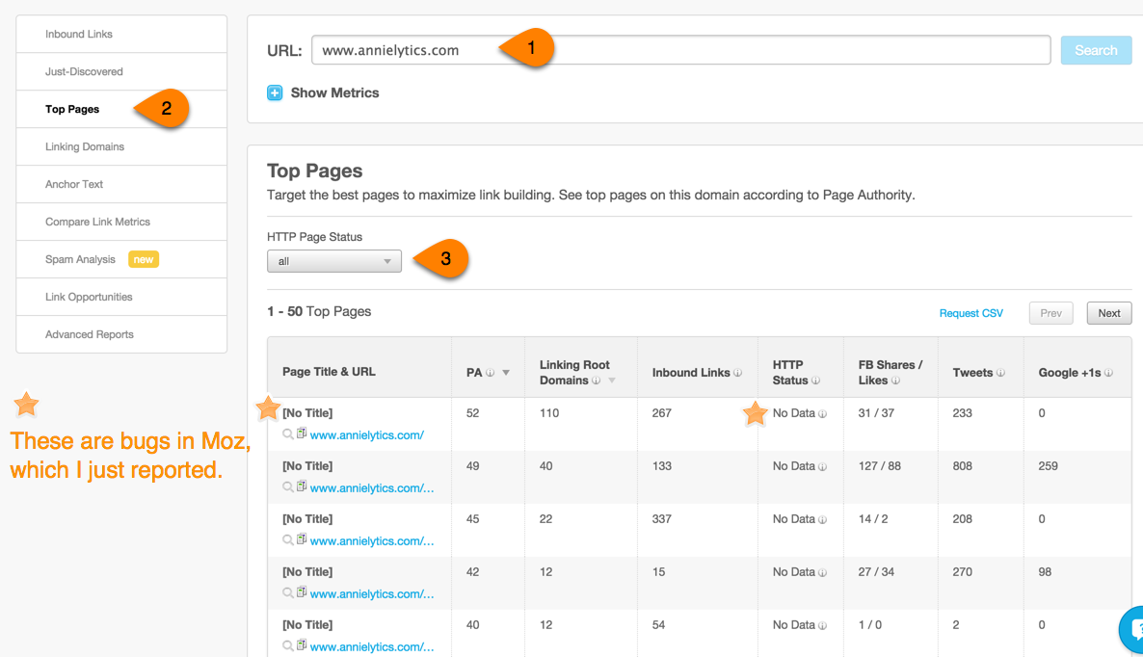

Alternatively, pull the Links to Your Site report in GWT (under Search Traffic).
Step 2: Pull internal links from GWT: Search Traffic > Internal Links and export them.
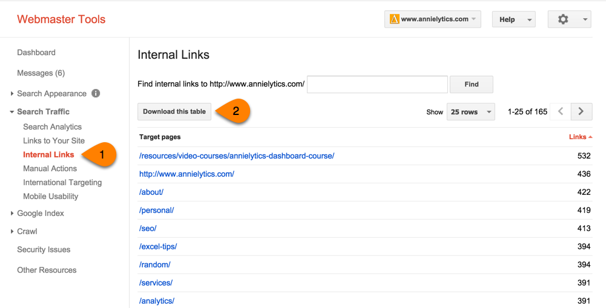
Step 3: Bring both worksheets into the audit-data.xlsx workbook and format them as tables.
Step 4: Add domain to the URIs from GWT (here’s a post where I describe how). You’ll need to do this to make the formatting of your URLs consistent so you can do VLOOKUPs with them (a v what?).
Step 5: Do a VLOOKUP to pull Page Authority from the OSE report into the Internal Links report from GWT. I used this formula:
=IFERROR(VLOOKUP([@[Target pages]],InternalLinks,5,0),"")
Note: In the worksheet this formula came from, I used a formatted table with a column title of “Target pages” and I created a named range that I called InternalLinks. To create the named range, I clicked a cell inside the table, pressed Ctrl/Command-A to select everything but the headings, and entered the name in the Name Box (to the left of the Formula Bar) in the upper-left corner of the interface. I also demonstrate this in my VLOOKUP video tutorial.
If you’re more comfortable using INDEX/MATCH over VLOOKUPs (they’re MUCH more flexible), I also did a tutorial on how to rock them. (The VLOOKUP video is 18 minutes and goes from simple to advanced techniques; the INDEX/MATCH video is 14 minutes. Both of these skills are very important for marketers worth their weight in gold to master.)
Step 6: Look for any URLs that have a lot of internal links but low Page Authority (or a lot of inbound links). Conversely, look for redheaded stepchild pages with a lot of inbound links but few internal links.
[/INVESTIGATE]

Pages in the site pointing to 404 pages
[INVESTIGATE]
In Screaming Frog, filter by your 4xx pages (and then 5xx pages), then look at Inlinks for key pages. You can use the View filter that sits on the upper-right corner of the report to find a particular 4xx or 5xx page.
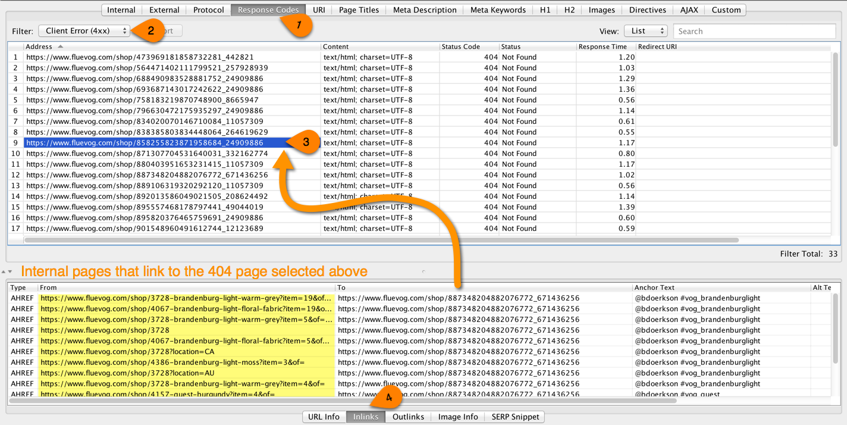
[/INVESTIGATE]

Links with non-relevant anchor text
[INVESTIGATE]
Run the site through ahrefs.com, then scroll down to the Anchors Cloud to see a distribution of anchors pointing to your site.
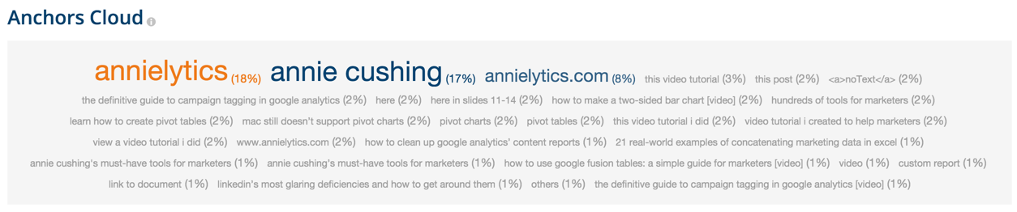

ahrefs’s Anchor Phrases and Anchor Terms reports are also very insightful to this end.
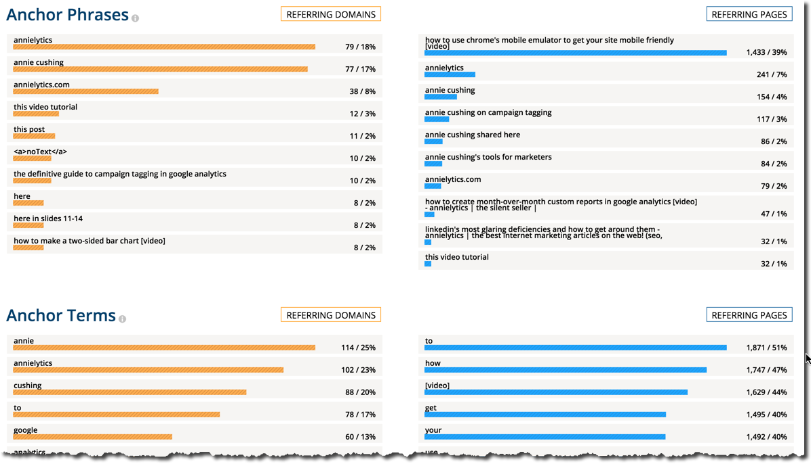

[/INVESTIGATE]

Pages with too many links
[INVESTIGATE] Screaming Frog: Internal tab > Outlinks column (not External Outlinks). Reorder by clicking on the heading so that the pages with the most links are at the top of the table. Do any of them include more than 100 links? Is so, export the Internal tab and filter in Excel to show only pages with > 100 links and add that worksheet to the audit-data.xlsx workbook.
Google doesn’t penalize for having more than 100 links on a page anymore, but it can still be a signal that the page is spammy. You can watch Matt Cutts split hairs in this video.

Site doesn’t link to category pages enough
As mentioned in the Architecture section, sometimes the most qualified page to rank for some keywords — particularly highly competitive head terms — is a category or tag page.
To see what kinds of pages are competing for a term you want one of your pages to rank for, simply search for that term in an incognito browser and see what types of pages populate page 1 of Google (or whatever search engine you’re targeting).
One way to bolster your category pages is to make sure every URL in that category links to its corresponding category page. This can be accomplished with editorial links (IOW, links in the content itself), breadcrumbs, and/or links in template, as you see below with Moz:
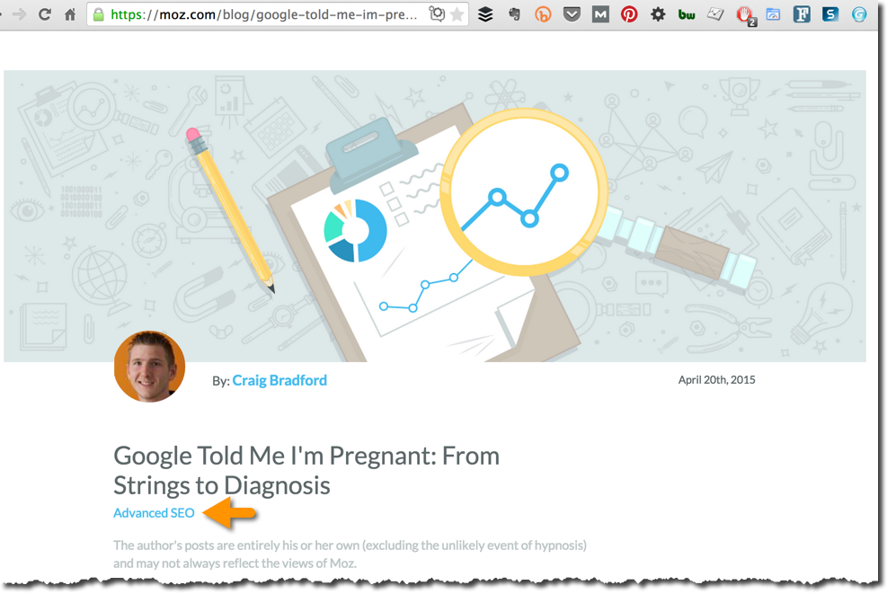

Daisy-chain URLs
[INVESTIGATE] Screaming Frog: Reports > Redirect Chains. Kill these in a fire.

Blog doesn’t link often to money pages
[INVESTIGATE] Good examples of internal linking: searchengineland.com, seoroundtable.com, outspokenmedia.com.

Links are served with JavaScript
[INVESTIGATE]
Links should use HTML, not JavaScript. To test this, disable JavaScript using the Web Developer Toolbar, then click on some links.
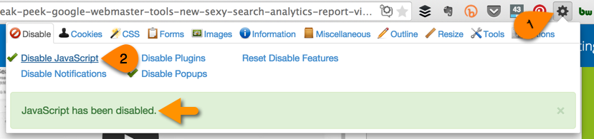
[/INVESTIGATE]

7.2 Recommendations
Recommendation 1
Recommendation 2
Recommendation 3

8.0 Inbound Links
Inbound Link Issues
Implementation Priority
Content Support | No
Technical Support | Yes

One of the single most important elements of the Google ranking algorithm is the quantity and quality of inbound links (IOW, links from other sites to yours). Google also looks at the anchor text, surrounding text, alt text in images, page topic, and linking site topic as signals that determine what keywords a page should rank for.
There are a number of qualities search engine algorithms key in on:
Quantity: The total number of links coming in.
Authority: How high is the authority of the sites linking to your site, and where are the links coming from? Links from boilerplate areas of the site, like the footer, are considered lower quality than editorial links, as WordPress learned the hard way.
Topical Relevancy: How relevant is the page linking to yours?
Anchor Text: The text of the link pointing to you. Search engines also look at the text immediately surrounding a link for topical clues.
Velocity: The rate at which new links are created and/or discovered. If your site creates content that goes viral or is highly relevant to current events, spikes are to be expected. But those spikes better be validated with other signals, such as social shares. Outside of virality, consistency (and staying below the radar) is key.

8.1 Issues

Overly optimized and repetitive anchor text
[INVESTIGATE]
Create word cloud of anchors. And replace my examples below with your own.
Your link profile should have a healthy mix of anchor text pointing to your site: branded anchors (e.g., Annielytics, annielytics.com, or Annie Cushing’s site for me), exact match (e.g., Excel dashboards), topical match coming (awesome dashboards in Excel), naked URLs (http://www.annielytics.com/resources/video-courses/annielytics-dashboard-course/), and junk links (e.g., learn more about Annie’s dashboard course here).
[/INVESTIGATE]

Decline in inbound links
[INVESTIGATE]
Check out the Referring Pages charts from ahrefs.com. Here’s an example from my site:
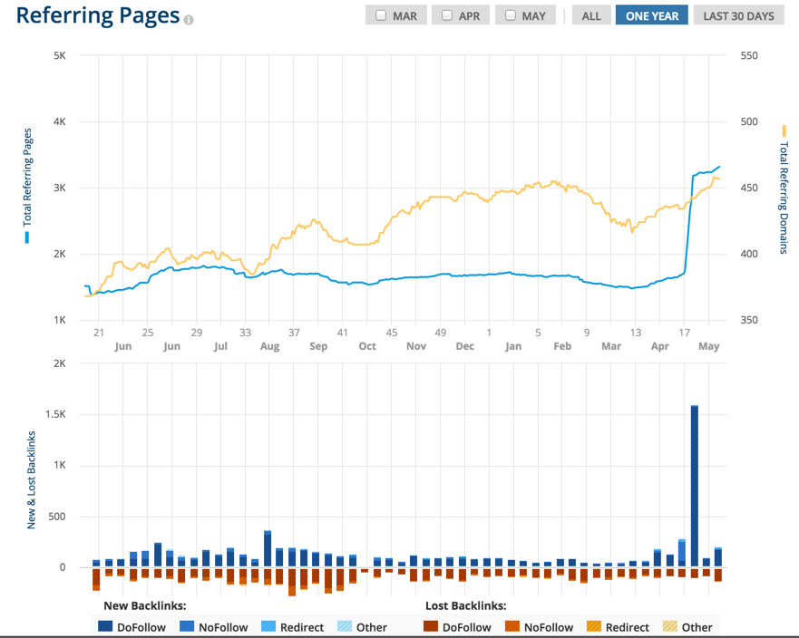
[/INVESTIGATE]

Site contains spammy links
[INVESTIGATE]
Moz assigns a spam score that can be used to assess how spammy a site is. You can click through to see Moz’s analysis of the site, like you can see below:
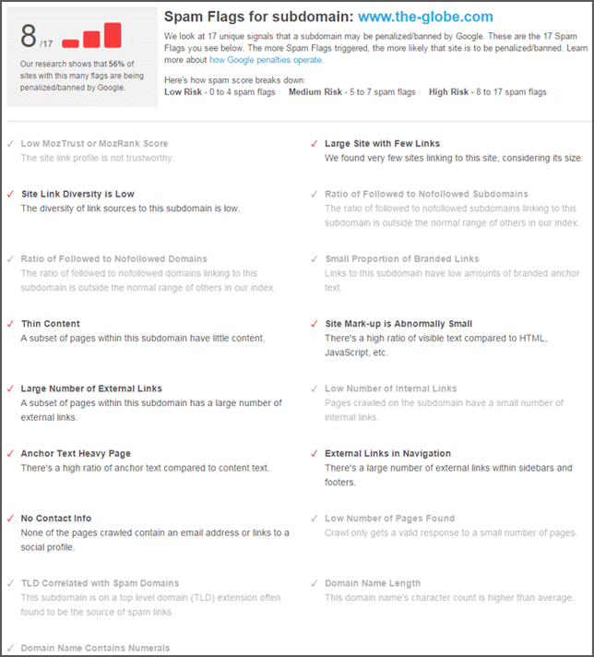
Source
Moz will also auto-generate a disavow file for you. But you need to make sure you go through it to make sure you’re not disavow anything you should keep. You can learn more about this tool from this Moz blog post by Rand Fishkin.
[/INVESTIGATE]

Suspicious ratio of homepage to deep links
[INVESTIGATE]
Each site should have a healthy balance of links to their homepage (usually with branded anchors) in comparison to links to their money pages. I once worked on a site that had 30k links to their health insurance page that all had the anchor health insurance and fewer than 10 branded links to their homepage. It was the most egregious example of a painfully obvious signal to Google that their backlinks were contrived, as opposed to links that are genuinely earned because of quality content, services, deals, etc. But examples like this aren’t uncommon with sites that were “optimized” prior to the Penguin update circa April 2012.
[/INVESTIGATE]

Best linkable assets
[INVESTIGATE]
Look at top linking pages from any one or more of the tools below:
OSE: Top Pages report (Read more in the Internal Links section of the report.)
Majestic: Pages tab
GWT: Search Traffic > Links to Your Site > Your most linked content
Searchmetrics: Social > Social Links > Social Spread
Buzzsumo
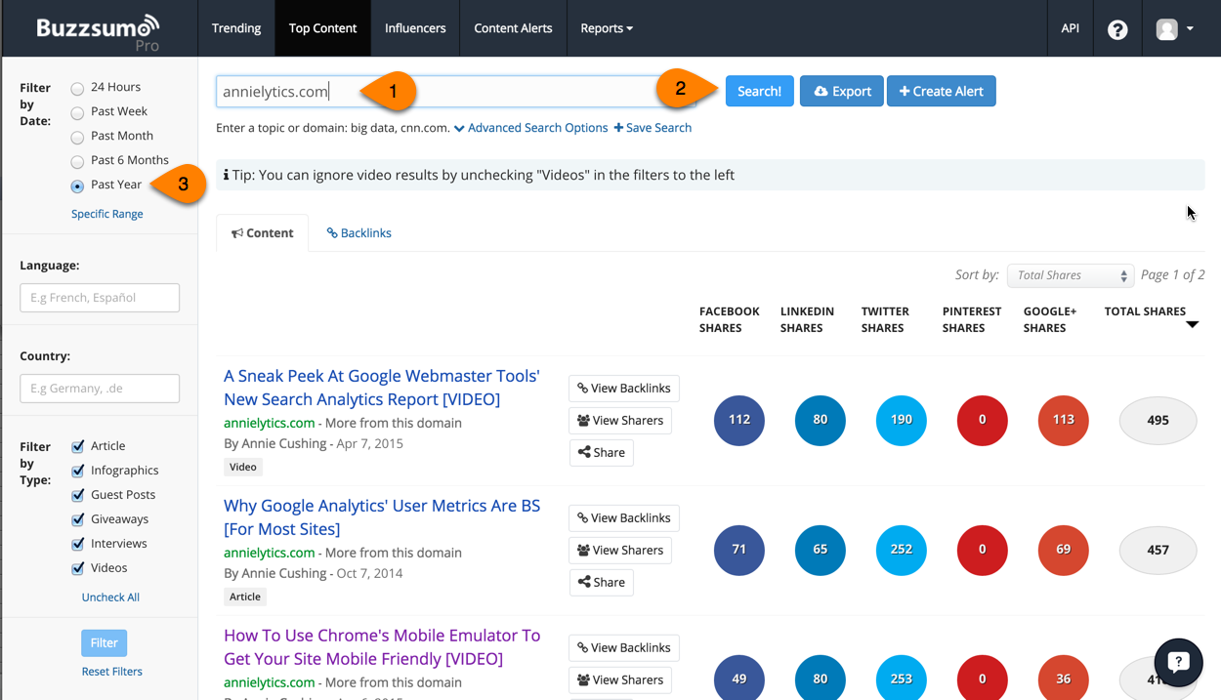
Check to make sure these pages don’t have excessive outlinks on them and that the links on these pages are strategic. To see your outlinks, open up Screaming Frog, and from the Internal tab, click a link and then scroll down to the Outlinks tab at the bottom of the report.
[/INVESTIGATE]

Linkable assets aren’t top organic landing pages
[INVESTIGATE] Look to see if top organic landing pages are receiving adequate internal and inbound links. These could be ideal candidates for link building campaigns.

Links to non-canonical URLs
[INVESTIGATE]
You don’t want to link internally to non-canonical pages. Sometimes this happens, where someone will set up a link to non-www version of a page when the canonical page is the www version. Or they’ll link to the non-secure (http) page when the canonical version is the secure version (https).
To find these internal links, in Screaming Frog select the Directives tab and set the filter to Canonicalised. Learn more about how to use this report in the Sitemaps section of the audit template.
[/INVESTIGATE]

Lost backlinks because of broken (404) pages on the site
[INVESTIGATE] Pull list of target URLs from backlink report (these are the URLs on your site that are receiving the backlinks), and run them through Screaming Frog to find 404s and 500s. You can upload a list of URLs by switching to List mode (Mode > List) or paste your URLs in. You can recover a lot of good links by fixing broken 404 pages.

Microsite backlinks put site at risk of getting penalized
[INVESTIGATE]
Sometimes site owners buy other sites with the express purpose of linking back to their main site. This can put the main site in danger. Google’s algorithm is designed to detect any signs of contrived SEO efforts designed to make a site look more authoritative than it actually is.
If you own microsites make sure you’re not linking back to the main site with optimized anchors. I was able to find a company’s link scheme just using Reverse Internet. If I could find it, you know Google’s algorithm can. Google has much more powerful tools at its disposal than Reverse Internet. </statements of the obvious>
Here’s an example of how you can use Reverse Internet to identify associated sites:
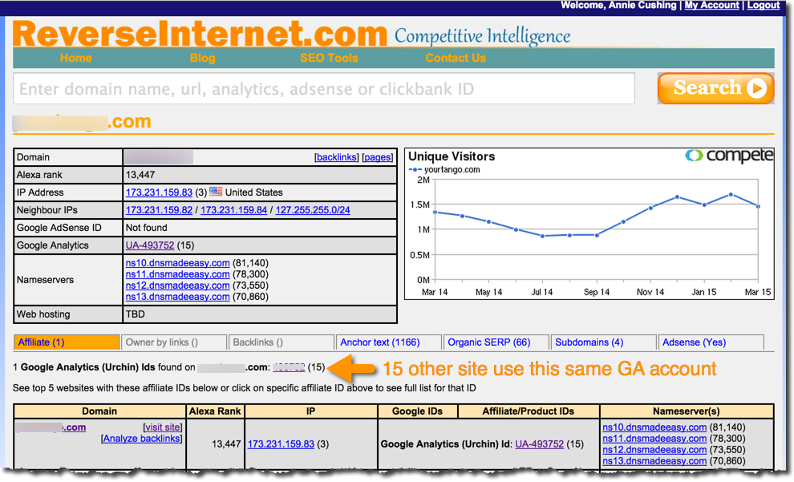
These other domains are listed under the Affiliate tab, but you should also check out the AdSense tab if the client’s site uses that service.
[/INVESTIGATE]

Site missing DMOZ link
[INVESTIGATE] Search for yourdomain.com site:dmoz.org or use the SEO Site Tools Chrome extension: External Page Data.
The DMOZ directory is one of the oldest on the Web and still passes PageRank. The process of submitting your site is pretty simple. Start with their submission page. You can submit your site for more than one category.

Site missing link(s) from Wikipedia
[INVESTIGATE]
Search Google for [ site:wikipedia.org link:yoursite.com ]. (Don’t include brackets.) This query will show you all of the links pointing back to your site from Wikipedia. If you don’t have one, you’ll see something like this:
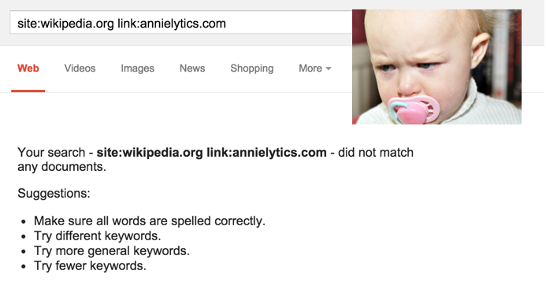
[/INVESTIGATE]

8.2 Recommendations
Recommendation 1
Recommendation 2
Recommendation 3

9.0 Semantic Markup
Markup Issues
Implementation Priority
Content Support | No
Technical Support | Yes

Using schema with microdata in a site’s HTML to declare specific elements allows search engines to better understand the meaning of its content and provide it with higher visibility in the search results through rich snippets. A rich snippet is essentially a bite-sized summary of the content that a user can expect to see on a page.
These snippets come in different forms: an image of a video screenshot, information about a concert, star ratings, cooking time for a recipe, etc. But all serve the purpose of providing sneak peek of the content on your site.
These snippets are highly coveted because there’s anecdotal evidence that they improve click through rates. They can also help reduce your site’s bounce rate because people will know they are interested in your site before they click.
In general, it’s recommended to start using the following microdata when specifying this type of content in HTML:
Address
Breadcrumbs
Authors
Events
Product reviews
Product information
Ratings
Videos
This content can be validated through the Structured Data Testing Tool inside GWT.

9.1 Issues

No structured data
[INVESTIGATE]
In GWT, open the Structured Data tool (under Search Appearance). This report will list the structured data Googlebot has found on the site.
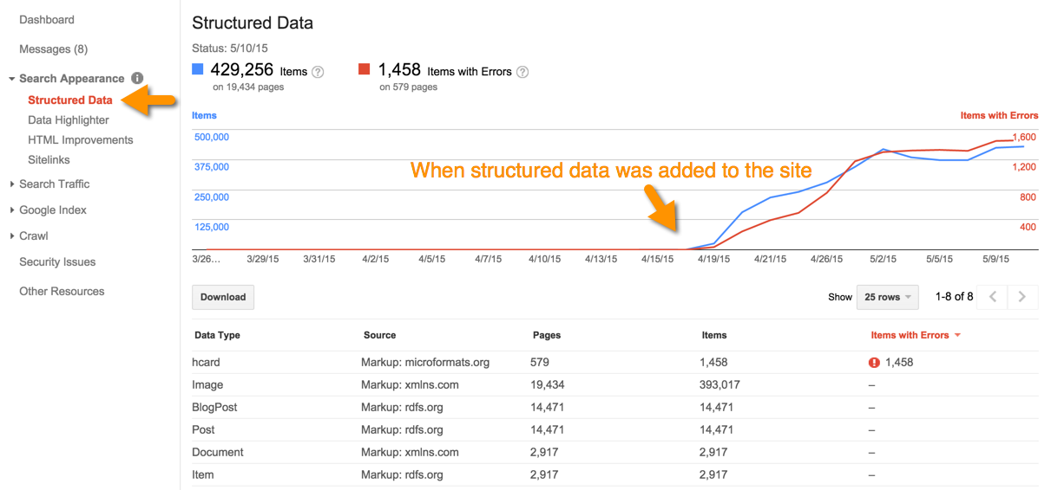

If no structured data is identified, evaluate if the site should contain markup.
You can also check to see if the site has markup using Screaming Frog: Configuration > Custom.

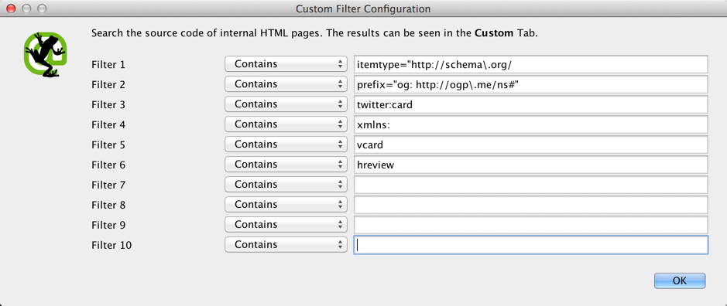
You can get the snippets to run in the Structured Markup section of the audit template.
[/INVESTIGATE] Search for your keywords on the Sindice search engine. Only sites that are using structured markup will show up in results. The type of markup they're using is listed. (RDFA = FB Open Graph)

Content worthy of rich snippets
[INVESTIGATE] Does the site have content that's rich snippet-worthy that schema.org supports (e.g., video, reviews, ratings, recipes, author, event, product, offer, etc.)?

Errors in Structured Data
[INVESTIGATE] GWT: Search Appearance > Structured Data. Report errors.

Site missing markup for local business
[INVESTIGATE] If your site is a local business, it should have business markup. You can generate the markup using the Microdata Generator.

Structured markup isn’t resulting in rich snippets
[INVESTIGATE]
Look to see if there’s structured markup on the site that’s not getting rich snippets, like reviews, ratings, author, etc. Then check out the Structured Data report in GWT to see if it’s registering as an error there.
You should suggest that the site owner or client uses the Data Highlighter tool (also under Search Appearance) to correct the markup.
[/INVESTIGATE]

9.2 Recommendations
Recommendation 1
Recommendation 2
Recommendation 3

10.0 Images
Image Issues
Implementation Priority
Content Support | No
Technical Support | Yes

Images offer a great opportunity to earn visibility and additional organic traffic with image and universal search results.
The use of images on the site is also helpful to make pages more attractive, illustrate an idea, and earn visitors’ attention.
Below are a few best practices in optimizing images for search:
Include ALT descriptions using specifically relevant keywords for each image, without keyword stuffing them. These are primarily for the benefit of visitors with disabilities using screen readers.
Optimize images file names so they include relevant keywords.
Include images in your XML sitemap following the multi-format sitemap specification or (better) create an image sitemap and submit it to Google and Bing.
Read more about Google’s recommendations for image optimization.

10.1 Issues

Images are on a different sub/domain
[CLIENT]’s images are all hosted on a subdomain, http://subdomain.clientsite.com. Rand Fishkin, founder of the SEO think tank Moz, did a seminar on image search strategies where he specifically talked about the importance of keeping images on the same subdomain as the content you want to have ranked. He talks in the seminar about how Facebook developers saw a reduction in visits from image search after moving their images to a subdomain. (You can buy the seminar here, if you’re interested.)
If you have load balance issues, you can load balance behind the firewall and have a separate server power your images. Whatever it takes on the backend, just have them show up close to the pages you want to rank in image search.
When I searched Google Images for [CLIENT].com (link pulls up a search results page of all the pages from the [CLIENT] site that are indexed in Google’s images index), all of the images were from the [CLIENT] subdomain [EXAMPLE].
To measure the impact of not having images hosted on your main subdomain, I did a search in Google Images for [KEYWORD]. [CLIENT] didn’t rank for at all for this query.

Large images
[INVESTIGATE] Click on the Images tab in Screaming Frog and set the filter to Over 100 kb. To convert the numbers in the Size column to kb, divide by 1028.
With SEO being inextricably tied to user experience, search engines are trying to motivate webmasters to make their sites easier to use by adding page load time as a ranking factor. (Learn more in the Site Speed section of the audit.)
One factor that can bloat page load times is large images. In the rush to publish, it’s easy to overlook image size. However, great care should be taken to make sure images are under 100KB (and even smaller if you have an entire page of images).

Images with no or irrelevant ALT text
[INVESTIGATE] Screaming Frog: Bulk Export > Images > Images Missing Alt Text and All Image Alt Text.

No image sitemap
[INVESTIGATE] Sites that contain high-quality images should employ a separate image sitemap.

Visibility for image search
[INVESTIGATE]
Check out the keywords the site is ranking for in image search. In GWT, follow the steps detailed in the screenshot below.
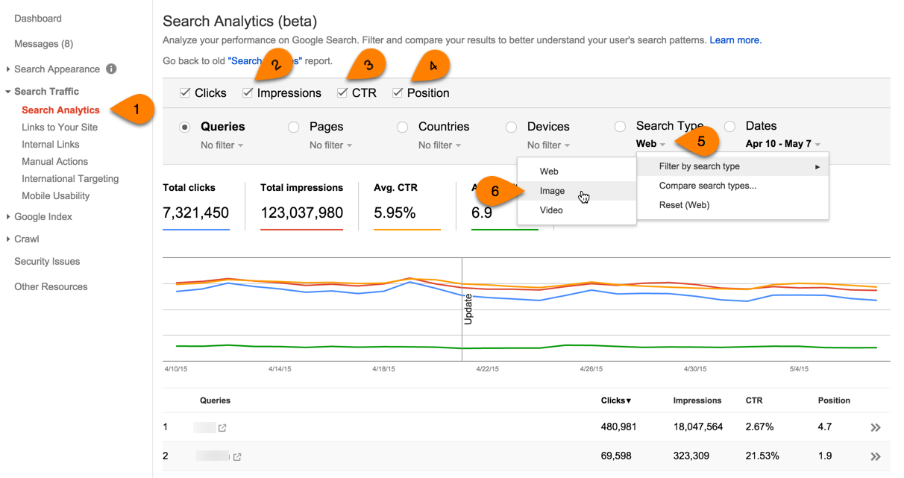
[/INVESTIGATE]

10.2 Recommendations
Recommendation 1
Recommendation 2
Recommendation 3

11.0 Video
Video Issues
Implementation Priority
Content Support | Yes
Technical Support | Yes

Videos offer a great opportunity to earn visibility and additional organic traffic with video or universal search results.
Below are some video best practices to keep in mind to maximize impact and reach in the search engines:
Optimize all the video related elements — titles, description, categories, keywords, etc. — with your target keywords, not only in the site but also in popular video platforms, such as YouTube or Vimeo. Just keep in mind that putting your videos on YouTube will sabotage your own site’s traffic. However, YouTube is the second largest search engine, so oftentimes it’s worth losing out on the traffic to your site.
Use structured markup to mark up your videos.
Add videos to your XML sitemap following the multi-format sitemap specification or create a new specific video sitemap and submit it to the search engines.
If you’re using YouTube to host your videos, there are a number of ranking signals YouTube uses for its videos. You can see them in the infographic below by Tag SEO:
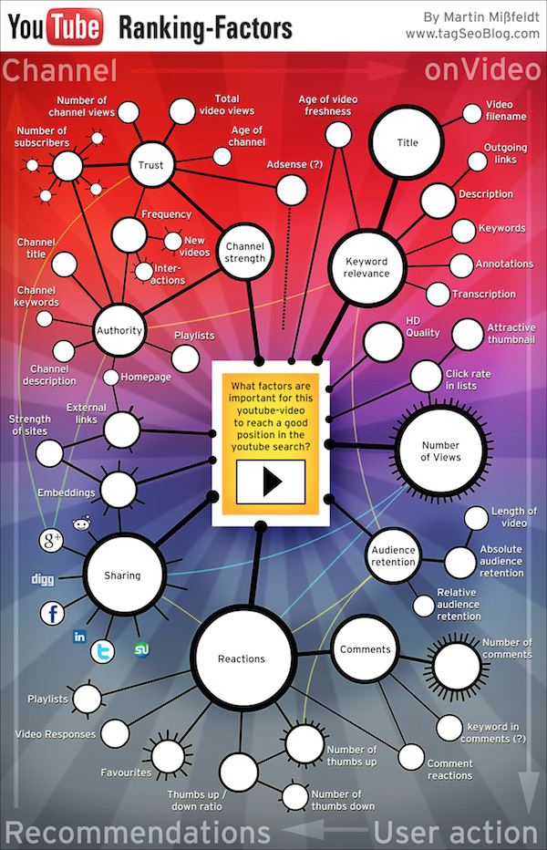

11.1 Issues

Commercial and/or promotional videos on YouTube
YouTube is a great platform for videos that are more viral in nature, as well as tutorials. However, videos with a commercial or promotional purpose tend not to do well on that platform. Furthermore, a site rarely benefits from the rich snippets you can get when you embed videos on your site. That’s because Google, with rare exception, shows preferential treatment to the video on the YouTube site over the embedded YouTube video on your site.
Going with a hosting platform like Wistia.com is more beneficial for sites creating their own videos as [CLIENT] is doing. This is because you’re not competing against Wistia for views. Also, Wistia automatically creates an XML sitemap for video, which is very convenient since there are very few tools that will automate the creation of video sitemaps.

Missing video sitemap
[INVESTIGATE] If you’ve embedded videos that are hosted on your site or are hosted on a video-sharing site that isn’t open to its own searches, you should use a video sitemap. You can learn more about how to generate video sitemaps here.

Videos not marked up
[INVESTIGATE] You should use schema.org or some type of markup to help search engines identify your videos.

Image sitemap showing errors or not submitted to search engines
[INVESTIGATE] You can use this sitemap validator to test your sitemap.

Videos clustered together on pages
You should only have one video on a page, with rare exception. It’s not as big of an issue if you’re embedding a YouTube video since your site is unlikely to get the coveted rich snippet. But if your video(s) are hosted on your site, you should limit your pages to contain one video per page to increase your chances of earning the rich snippet.

Video pages lack text
If a video is embedded into a page that’s lacking content, it will have a difficult time performing in search. This is because the search engines are reliant on text on a page to determine what it’s about and what queries it should show up for. One way to do this is to write content around the video. I will frequently do this with my video tutorials. It’s good for visitors, search engines, and you (when you benefit from the traffic and conversions).
For example, here’s an example of a video tutorial Annie Cushing did on how to use Chrome’s mobile emulation tool (a must-have tool when doing analysis around mobile sites). To give visitors a taste of what they’ll learn in the video, she listed some of her fave features. And in this video tutorial she did on rocking Google’s fusion tables, she breaks down the tutorial by minute markers. This can be a user-friendly option for longer videos or subjects that viewers might find more intimidating to marketers.
Another option is to provide a transcription of the video. Moz does this well with their videos, as you can see in this this sample Whiteboard Friday video. One tool you can use to generate these transcriptions is Screechpad. But before you move forward with transcriptions (the best option for the search engines by far), a few caveats:
Transcription services are as flawed as the technologies and transcriptionists they use. Don’t treat them in a set-it-and-forget-it manner. Transcriptions should be reviewed to make sure they read well and make sense.
If you hide the transcription on the page using jQuery’s collapsible content or accordion, after the page is indexed (which you can test by entering site:yoursite.com/your-video-page/ into Google), see if content from the transcription is indexed. Google has been unpredictable in indexing content that needs to be expanded or is hidden by tabs. You can run this test by taking a snippet of text from the transcript, enclosing it in quotations, and searching for in Google. Alternatively, you could look at the text-only version of a cached page to see how search engines view a page. I demonstrate how to do this in this animated gif using the Mozbar.
You’ll want to make sure you remove all fillers — like um, uhh, you know, etc. — from the transcription, as well as false starts.

Video player isn’t mobile friendly
[INVESTIGATE]
If you’re hosting your own videos, your site should use an HTML5 player. It’s mobile friendly because it’s lightweight. Flash should be avoided like the plague.
If you’re hosting your videos on Wistia you can use their responsive embed code.
[/INVESTIGATE]

Missing tags on YouTube channel
[INVESTIGATE] This resource published on Search Engine Watch is a great primer in how to use tags on YouTube. But the client should be using tags liberally as they’re good for search as well as good for users.

Missing call to action for people to comment on the video
YouTube makes it easy to add annotations that encourage viewers to like videos and subscribe to your channel. You can add annotations that prompt viewers to also comment on your videos. It’s important to vote up and engage with people who comment on your videos. Video responses show YouTube that your video is popular and relevant. Replying demonstrates you’re approachable.

Missing links to other YouTube videos in annotations
These links can be added using annotations with links to your other videos. There's anecdotal evidence that YouTube favors videos that link to other YouTube assets within annotations.

Lack of [keyword-rich] playlists
If you have videos that naturally cluster around a particular topic, you should consolidate these into playlists. Well-architected playlists perform well in search engines. They should also be embedded on your site. You can see an example of an embedded playlist in a blog post from Annie Cushing’s blog.

Missing link to site in YouTube description
YouTube allows you to include links in your descriptions. This is a great way to nudge people to visit the blog post your video is embedded in for more information. A few tips:
- Include the link early in the description. Here’s an example of how these URLs can be included:
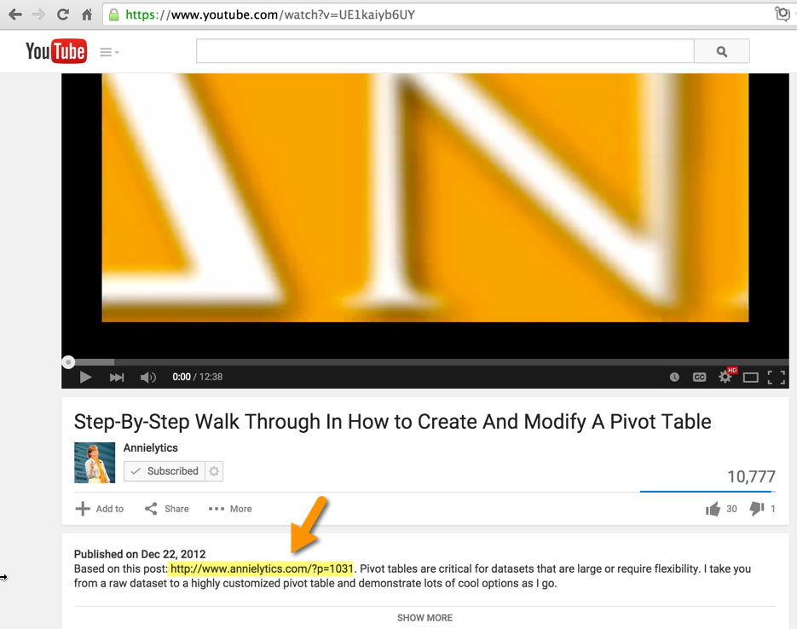
- Shortlinks in WordPress work well for these URLs because they’re shorter than permalinks but more transparent URLs obfuscated by URL shorteners.
- Make sure you include the protocol (http or https), or the link won’t be clickable.

Missing link on site to video channel
It goes without saying that if your brand has a YouTube channel, you should include a link to your YouTube page in your site template. Even better: Consider adding the ability to subscribe to your channel right from your page/site using a Subscribe button, as shown on Annie Cushing’s site below:
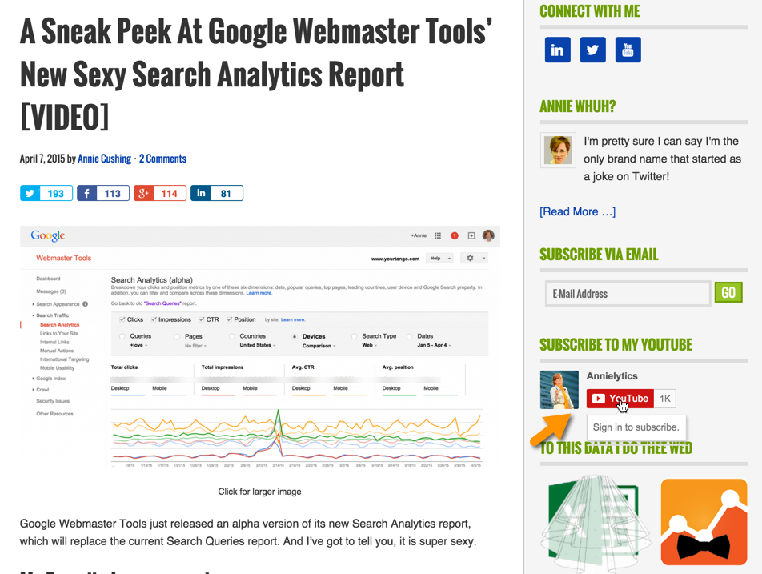
You can configure the code for your site from the Google Developers site. (Scroll down to Configuration options to set yours up. No developer resources necessary.)

11.2 Recommendations
Recommendation 1
Recommendation 2
Recommendation 3

12.0 Titles
Title Issues
Implementation Priority
Content Support | Yes
Technical Support | Yes

Title tags (technically called title elements) define the title of a document and are required for all HTML/XHTML documents. It is the single-most important on-page SEO element (behind overall content) and appears in three key places: the title bar of a browser, search results pages, social sites:
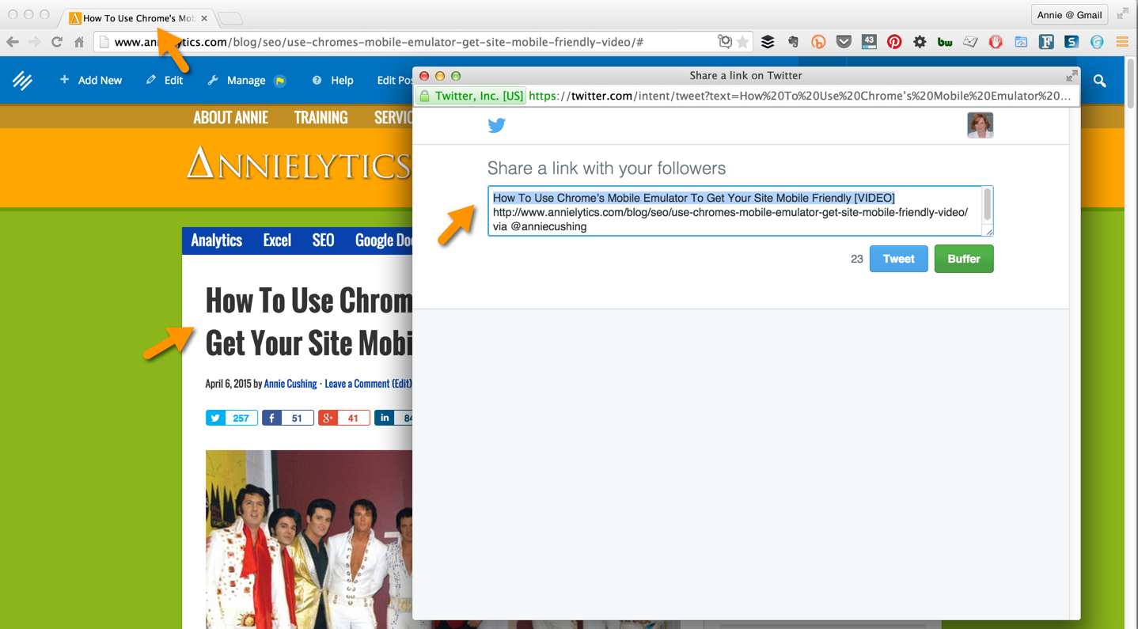

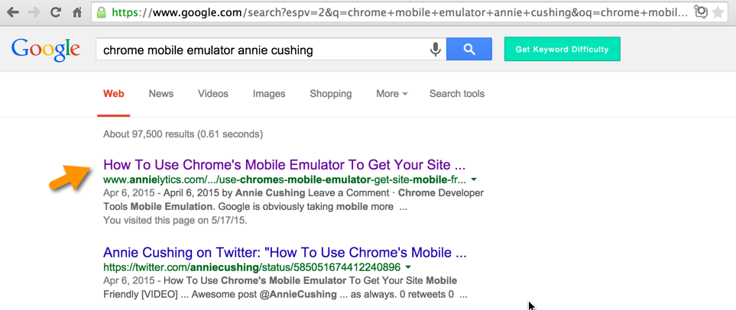
As a ranking factor in organic search and a highly visible element to users in the search engine result pages (SERPs), it’s important to make sure that a site’s titles meet certain criteria:
- They’re relevant, descriptive, and unique for each page.
- They read effortlessly. Titles with keywords separated by pipe characters, for example, aren’t good for social sharing or click throughs from search results.
- They’re different from the meta description and offer complementary information.
- They include the most important keywords for each specific page, preferably toward the beginning of the title (but aren’t keyword stuffed!).
- They include the name of the site at the end of the title to strengthen its branding.
- They’re concise since search engines only show the first 65 – 70 characters.

12.1 Issues

Pages with missing titles
[INVESTIGATE]
Use Screaming Frog to identify pages with missing title tags.
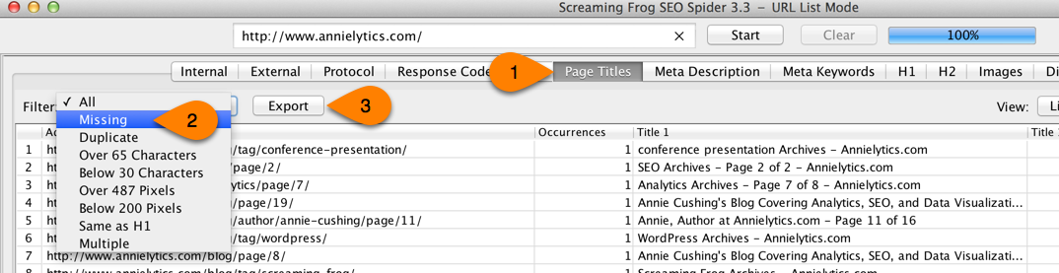
[/INVESTIGATE]

Pages with long titles
[INVESTIGATE]
You can use Screaming Frog to identify pages with long titles.
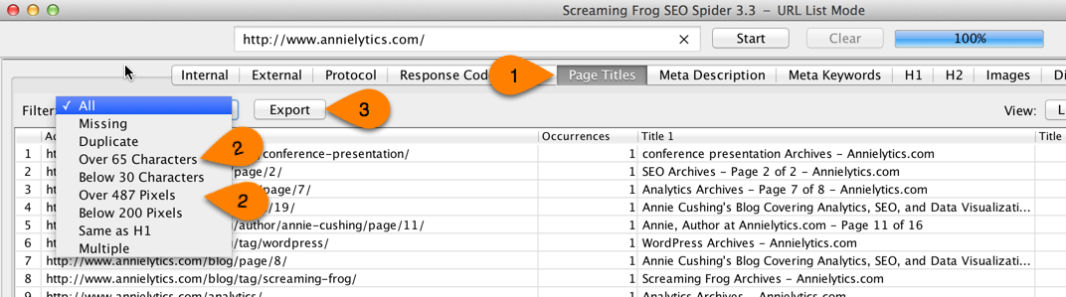
[/INVESTIGATE]
You should keep your page titles under 65 characters (or 487 characters) to be safe. If you don’t, your page titles could be truncated in the SERPs, which has been correlated with lower click through rates.
You can find them in the audit-data.xlsx workbook under the Long Page Titles tab.

Pages with short titles
[INVESTIGATE]
You can use Screaming Frog to identify pages with short titles.
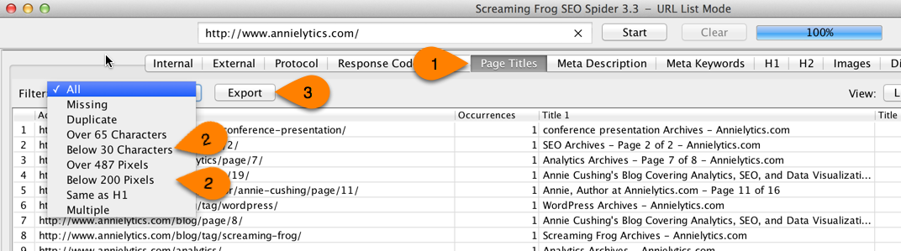
[/INVESTIGATE]
[CLIENT] has [NUMBER OF PAGES] with page titles that are shorter than 30 characters. Excessively short page titles can fall short of adequately communicating what content a viewer can expect to see when s/he clicks through.
Many of these are pages that should be blocked from the search engines anyway, as recommended here.

Duplicate page titles
[INVESTIGATE]
You can use Screaming Frog to identify pages with duplicate titles.
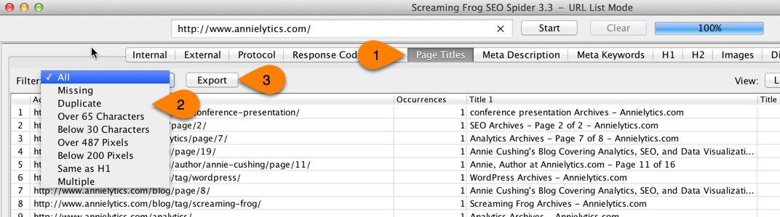
[/INVESTIGATE]
Pages with duplicate titles are oftentimes good indicators of duplicate content (which was covered in the Canonicalization section of the audit).

Odd capitalizations in titles
Page titles typically use title case. Whatever case you choose to use, you should keep it consistent. Capitalizing words just to emphasize them can make your page titles distracting and give your site an amateur appearance.

Pages with non-descriptive titles
[INVESTIGATE] You can use this custom Google Analytics report with landing pages and page titles to prioritize which page titles should be optimized first.
Since the page title is arguably the most important piece of real estate as far as SEO goes, writing titles that are both optimized and compelling is critical to both ranking and click throughs. Titles like the ones below don’t take advantage of the power the [CLIENT] team has to get its message out to a broader audience:
[EXAMPLES OF POOR PAGE TITLES]

12.2 Recommendations
Recommendation 1
Recommendation 2
Recommendation 3

13.0 Meta Descriptions
Meta Description Issues
Implementation Priority
Content Support | Yes
Technical Support | Yes

Although meta descriptions are not a ranking factor, they’re highly visible to users in the SERPs and can affect click through rates. Google highlights not only search query terms but also synonyms in meta descriptions, making these keywords pop off the page for searchers.
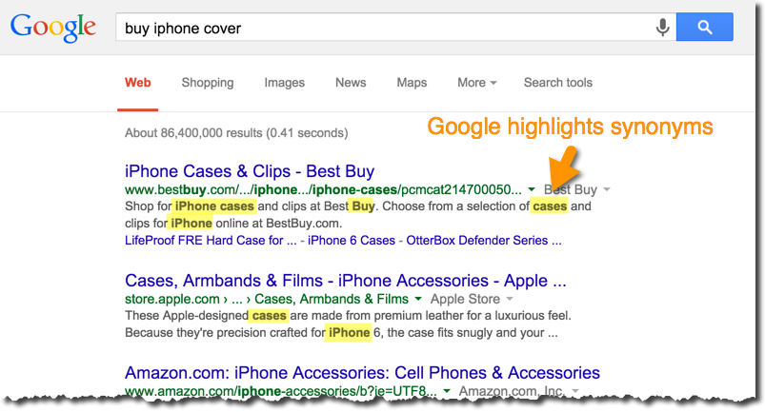
With this in mind, you should keep a few things in mind when writing meta descriptions:
They should have a compelling call to action or lure the searcher to click through.
They should be unique and describe the content of the page well.
They should be no more than 156 characters long since search engines truncate descriptions beyond this point (and sometimes before this point since Google uses pixel width instead of characters now).

13.1 Issues
[INVESTIGATE] Follow the directions for the Titles section. Screaming Frog offers all the same options for meta descriptions as it does for titles.

Pages with missing meta descriptions
The Missing Meta Descriptions tab of the audit-data.xlsx workbook contains pages that are missing meta descriptions. Any page that is intended to be public facing should have a meta description.

Pages with long meta descriptions
The Long Meta Descriptions tab of the audit-data.xlsx workbook lists pages that have long meta descriptions. Long descriptions will be truncated, reducing their readability and click through rates.

Pages with short meta descriptions
The Short Meta Descriptions tab of the lists pages that have short meta descriptions. Screaming Frog flags descriptions with fewer than 70 characters as short. Care should be taken to write descriptions that are adequately descriptive and compelling.

Odd capitalizations in descriptions
Meta descriptions should be written with a conversational tone that follows standard sentence case to aid readability.

Descriptions missing power calls to action
[INVESTIGATE] Pay special attention to homepage, category pages, and product/content pages. Alternatively, pull in titles and descriptions of top landing pages.
Many times sites focus the lion’s share of their time on ranking but fail to take into account the import of actually earning clicks from those ranking pages. Below are examples from your site of compelling meta descriptions:
[EXAMPLES OF GOOD META DESCRIPTIONS]
And below are examples from your site of subpar meta descriptions:
[EXAMPLES OF SUBPAR META DESCRIPTIONS]

13.2 Recommendations
Recommendation 1
Recommendation 2
Recommendation 3

14.0 Site Speed
Site Speed Issues
Implementation Priority
Content Support | No
Technical Support | Yes

On April 9th, 2010, page load speed officially became a part of the Google search ranking algorithm. For usability reasons, best practices dictate that a web page should load within 1-2 seconds on a typical connection. However, according to GWT data, a load time of 1.4 seconds is the threshold between a fast page and a slow page. That means, ideally, that every page on your website should load in 1.4 seconds or less, to receive the maximum SEO benefit for fast-loading pages.
Besides the ranking benefits, there are crawling benefits for faster sites. As discussed in the Crawl section of the audit, each site is assigned a crawl budget. When search spiders have exhausted that budget, they move on. There is a strong correlation between improving page speed and the search engines’ ability to crawl more pages.
Google gathers page load time data through actual user experience data collected with the Google Toolbar, Chrome, and Android and may also be combining that data with data collected as Google crawls a website. As such, page load speed in terms of the ranking algorithm is being measured using the total load time for a page, exactly as a user would experience it.
You can now view samples of page load times right in Google Analytics. It’s especially helpful to segment those page load times out by country as you can see in this report [LINK TO REPORT: BEHAVIOR > SITE SPEED > PAGE TIMINGS > MAP OVERLAY TAB].
A great resource for strategies to lower page load speed is GTmetrix’s Speed Performance report [LINK TO SITE REPORT FROM GTMETRIX]. It provides developers with very specific recommendations to improve site speed.

14.1 Issues

Page load times of top landing pages high
[INVESTIGATE]
Look at page load times of top 20 landing pages in Google Analytics. You can use this custom report I created, which includes sessions, avg page load time, bounce rate, total goal completions, and revenue by landing page.
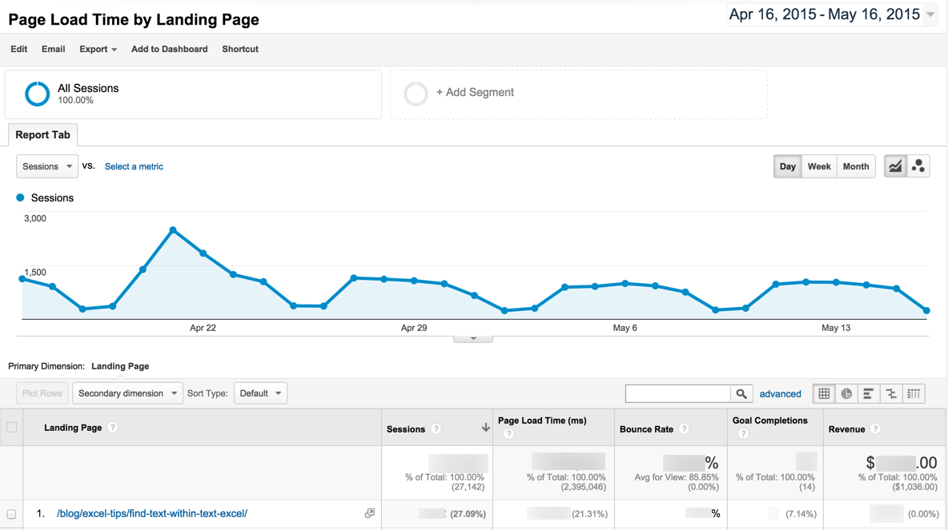
[/INVESTIGATE]

Page load times of money pages lag in comparison to competitors
[INVESTIGATE] You can use WebPageTest (WPT) to compare your homepage (or a money page) to three of your competitors. WPT will give you the option to export a video that demonstrates the four pages downloading vis-à-vis. Think horse race.

Page Caching
The [CLIENT] site does not leverage page caching. What caching does is reduce the page load time of your pages by storing commonly used files from your website on your visitors browser. This avoids potentially time-consuming queries to your database. It also helps lower server load by up to 80%.
Caching most visibly benefits high-traffic pages that access a database but whose content does not change on every pageview. Common caching methods include Alternative PHP Cache, Quickcache, and jpcache. Caching mechanisms also typically compress HTML, further reducing page size and load time. Get a full list of resources you can cache from the GTmetrix report for the [CLIENT] site [LINK TO REPORT]. You can read more about the benefits of caching here.
[INVESTIGATE] Use SEO SiteCheckup to check.

Site has pages greater than 35kb
The average web page size is 35kb. It’s a good goal to get your site’s pages under 35kb, which could lead to a faster than average page load time.
[INVESTIGATE] Use SEO SiteCheckup to check.

Excessive HTTP requests
[INVESTIGATE] Use SEO SiteCheckup to check Page Objects.
For optimal page load time, HTTP requests should be kept under 20. The homepage has [# FROM PAGE OBJECTS SECTION] objects it retrieves from a variety of servers:
- HTML pages:
- Images:
- CSS files:
- Scripts:
- CSS images:
The Yahoo Developer site lists recommendations to reduce the number of HTTP requests.

Site not using gzip compression
The [CLIENT] site does not appear to be using gzip compression. You should compress your HTML to reduce your page size and page loading times. This will help your site retain visitors and increase pageviews. Consider using GZIP to compress your HTML. The GTmetrix report for the [CLIENT] site contains specific resources it recommends for gzip compression that will reduce the size of the files listed by [X]%.
[INVESTIGATE] Use SEO SiteCheckup to check.

Site uses inline CSS
[INVESTIGATE] Use SEO SiteCheckup to check (Inline CSS Test).
Inline styles are CSS styles that are specified within the page code itself, as opposed to inside an external style sheet. Repeated use of inline styles leads to unnecessary code bloat and slower page loading. Using an external CSS style sheet that references these styles will lead to smaller code and faster page loading.
The [CLIENT] homepage alone uses [# OF INLINE STYLES] inline CSS properties! An inline CSS property is added by using the style attribute for a specific tag. By mixing content with presentation you might lose some advantages of the style sheets. Is a good practice to move all the inline CSS rules into an external file in order to make your page "lighter" in weight and decrease the code-to-text ratio.

Site uses inline JavaScript
[INVESTIGATE] Use GTmetrix to check.
If your site is using the same JavaScript code across multiple pages, you should consider using an external JavaScript file so that it will be cached by the user's browser for each of those page views. This will reduce your page's HTML size, as well as make your code easier to maintain.

Site doesn’t minify JavaScript or CSS
[INVESTIGATE] Use GTmetrix to check.
The [CLIENT] site doesn’t minify — or compress — its JavaScript or CSS files. Minifying these files removes unnecessary bytes on the wire.
While it's great to put comments, tabs and whitespace in code to improve readability and maintenance, these are bytes that take up space on the wire and that a browser has to parse unnecessarily. Minifying the site’s JavaScript resources could reduce their size by X%.
Below is a full list of your site’s JavaScript files, which you can view in this report [LINK TO REPORT]:
[FULL LIST OF JAVASCRIPT FILES]
There are free resources online that will minify your JavaScript and CSS files.

More recommendations from GTmetrix report
You can view more recommendations to reduce page load time from the GTmetrix report for the [CLIENT] site by navigating to this GTmetrix report [LINK TO REPORT].

14.2 Recommendations
Recommendation 1
Recommendation 2
Recommendation 3

15.0 Mobile
Google’s release of its mobile-friendly algorithm update on April 21, 2015, sent many site owners and marketers scrambling to get their sites—or at least key landing pages — mobile ready. Although the impact of the update was a bit lackluster by many marketers’ standards, the update did force site owners to take mobile issues much more seriously. And, to Google’s credit, they did release some really helpful resources to help site owners and marketers create mobile-friendly sites, like its fabulous Mobile-Friendly Websites guide.
There are a few key facts marketers and site owners should know about this update:
- It is assessed on a page-by-page basis in real time.
- Google’s mobile-friendly assessment is a Boolean value. Either it’s mobile or it’s not. There’s no in between.
- Google released a Mobile Friendly Tool to help marketers assess if their key landing pages were mobile friendly.
- Just the fear of Mobilegeddon resulted in a 5% uptick in mobile-friendly sites in the two months prior to the update.
- If a page passes the mobile-friendly test, it’s rewarded with a snippet in mobile search results.
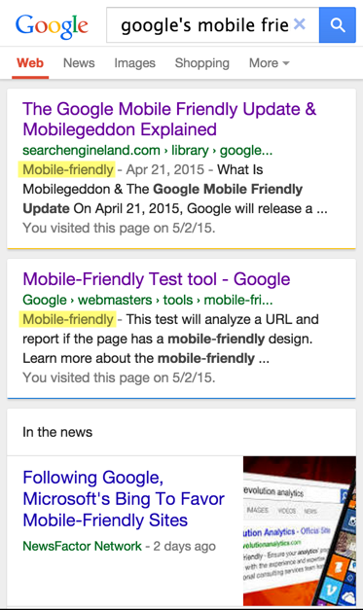
According to Google, to receive this coveted label, a page must meet the following criteria:
It avoids software that is not common on mobile devices, such as Flash.
It uses text that is readable without zooming.
It resizes content to the screen, so users don't have to scroll horizontally or zoom.
It places links far enough apart so that users can easily click the intended link.
Google’s advice to webmasters seeking to make their sites mobile friendly is broken down below:
Check your pages with the Mobile-Friendly Test.
Read Google’s Webmasters Mobile Guide on how to create and improve your mobile site.
See the Mobile usability report in Google Webmaster Tools, which identifies mobile usability issues across your site. This report will list specific pages where the different issues occur. Using Chrome’s mobile emulator, you can check out these issues for yourself.
Read Google’s Customize Your Website Software guide to learn how to customize a host of popular Content Management Systems — such as WordPress, Joomla, Drupal, etc. — to use a mobile-friendly template.
Completely apart from Google’s Mobile Friendly Update, sites should strive to serve up pages that are friendly to mobile users. If mobile visitors have a difficult time digesting your content, they will oftentimes grow frustrated by the poor user experience and leave your site. This will not only result is a reduction of traffic (as search engines could send less mobile traffic to your site) but also fewer social shares. All of these consequences have the potential of hitting an organization’s bottom line. Ergo, it is in the best interest of most site owners to make their sites into compliance.
[CREDIT] Huge kudos to Aleyda Solis for providing the lion’s share of the content for this section of the audit. She is a brilliant source for all things mobile and international SEO.

15.1 Issues

Site isn’t mobile friendly
[INVESTIGATE]
Run a handful of pages through Google’s Mobile-Friendly Test.
Also, navigate to the site via your smartphone, or as a smartphone in your desktop browser using Chrome's mobile user-agent emulator (which I did a video walkthrough of).
You can also W3C’s mobileOK Checker to test how mobile friendly a sampling of your site’s pages are.
[/INVESTIGATE]

Mobile visitors bounce at a higher rate
[INVESTIGATE]
Navigate to Mobile Overview report in Google Analytics (Audience > Mobile > Overview) and compare the bounce rates for your different device categories (to wit, desktop, mobile, and tablet).
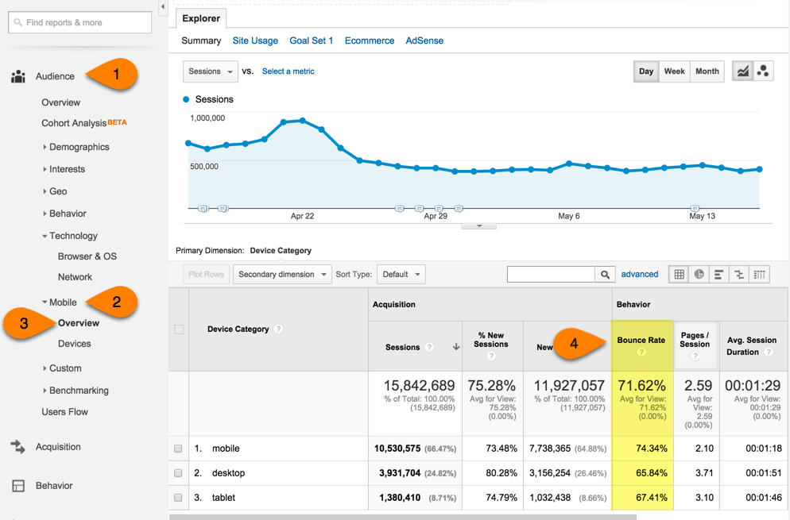
[/INVESTIGATE]

JavaScript and/or CSS are blocked
If your site is responsive, it’s important for Googlebot to be able to access your JavaScript and CSS. Check your site’s robots.txt file — which should be located at subdomain.yoursite.com/robots.txt — to make sure you’re not blocking these files. Google’s PageSpeed Insights tool (Mobile tab) will also let you know if you’re blocking these resources.

Dynamically served mobile site lacks Vary HTTP header
[INVESTIGATE] If different code is served depending on the user-agent, Google requests that the server send them a hint to crawl the page as Googlebot for smartphones in addition to desktop Googlebot. The way to send this hint is via the "Vary: User-Agent" directive in the server's response to a request. To see what this looks like, read Google's documentation.

Improper use of rel="alternate" and rel="canonical" tags
[INVESTIGATE]
If the [CLIENT] site uses separate sites for mobile and desktop, you should ensure that every mobile URL has a canonical tag pointing to its corresponding desktop URL. For desktop URLs, there are two acceptable implementations:
Adding a rel="alternate" tag, which refers to the corresponding mobile URL and includes the "media" attribute telling Google what screen size the mobile URL is meant for.
Adding rel="alternate" to each desktop URL's entry in the site's XML sitemap
See examples of both implementations here.
[/INVESTIGATE]

Mobile site missing sitemap
[INVESTIGATE] If you’re serving up separate mobile and desktop sites, you should have a sitemap(s) for both. And you need to submit all to the search engines and reference them in the site’s robots.txt file(s). (Remember: You also need a robots.txt file for each subdomain.)

Mobile site is showing up in desktop searches
[INVESTIGATE] If the mobile site is on its own domain or subdomain, do a search in Google for site:m.website.com (or wherever your site’s mobile site is located) on your desktop. This search should return no results. If mobile URLs are being served up on desktop, make sure you are including rel=”alternate” and rel=”canonical” annotations as directed by Google.

URLs don’t redirect to mobile/desktop counterpart
[INVESTIGATE]
Google’s advice on this topic:
HTTP redirection is commonly used to redirect clients to device-specific URLs. Usually, the redirection is done based on the user-agent in the HTTP request headers. It is important to keep the redirection consistent with the alternate URL specified in the page’s link rel=”alternate” tag or in the Sitemap.
For this purpose, it does not matter if the server redirects with an HTTP 301 or a 302 status code, but use of 302 is recommended whenever possible.
If HTTP redirection is difficult to implement, you can use JavaScript to redirect users to the URLs pointed to by the link rel="alternate" tag. If you choose to use this technique, please be aware of the latency caused by the client side of redirection due to the need to first download the page, then parse and execute the JavaScript before triggering the redirect.
There are many approaches to implementing a JavaScript-based redirect. For example, you can use JavaScript to execute the media queries your site already uses in the link annotations on the page using the matchMedia() JavaScript function.
Source
Google also shared the following graphic to illustrate how mobile redirects should look when fetched and rendered within GWT (Crawl > Fetch as Google):
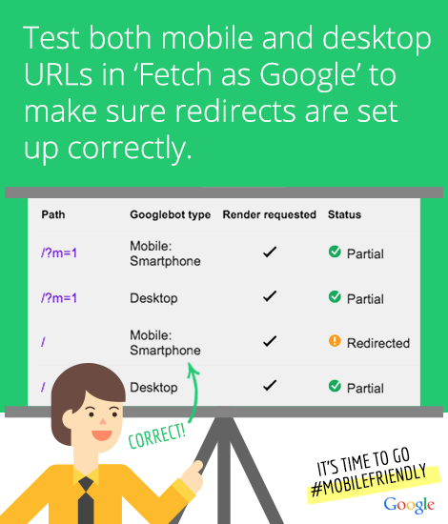
Another thing to keep in mind is server-side redirects tend to provide a better user experience for mobile users since speed isn’t dependent on the computing power of the mobile device.
[/INVESTIGATE]

Lack of choice between mobile and desktop
[INVESTIGATE] Google suggests giving users a way to override the redirect policy, i.e. allowing mobile users to view the desktop page and allowing desktop users to see the mobile page if they so choose.

Faulty redirects
[INVESTIGATE]
Glenn Gabe wrote a stellar post about smartphone demotions because of issues like this. In the post he writes about how he tried to open the page below on his mobile device:
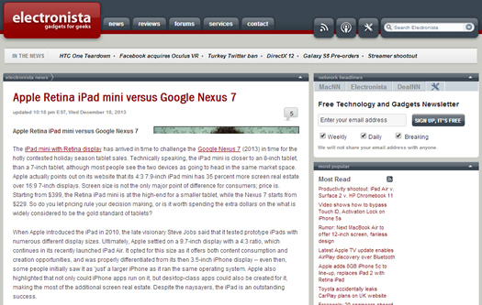
Instead of opening the page, the site redirected him to the homepage via a 302 (or temporary) redirect, as shown below:
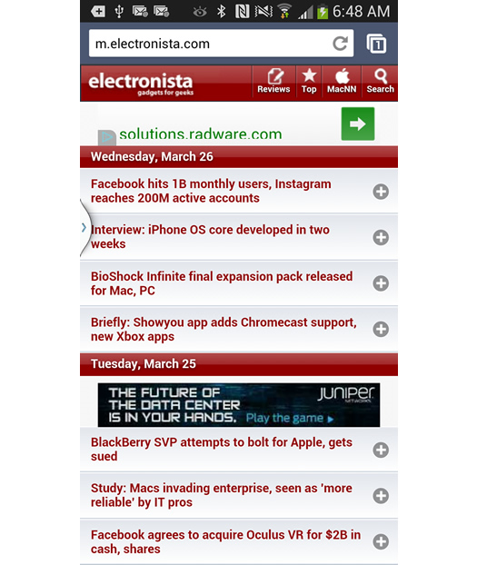
If you find issues like this, check the site out in SEMRush (which now records mobile and desktop rankings separately, as you can see in the screenshot below) to see if the site is experiencing a demotion.
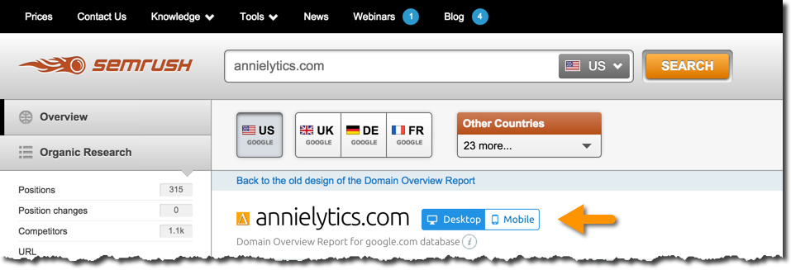
Also, check out the site’s Smartphone Crawl Errors in GWT (Crawl > Crawl Errors > Smartphone tab) to see if your site is using faulty redirects.
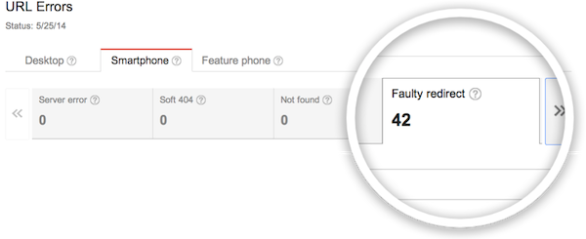
[/INVESTIGATE]

Site is experiencing mobile-only 404s
[INVESTIGATE]
Some sites serve content to desktop users accessing a URL but show an error page to mobile users.
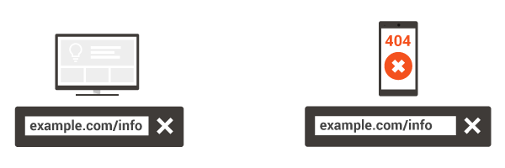
To ensure a positive user experience, if you recognize a user is visiting a desktop page from a mobile device and you have an equivalent mobile page residing on a different URL, redirect the visitor to that URL instead of serving a 404 or a soft 404 page. Also, make sure that the mobile-friendly page isn’t an error page.
To detect these issues, check the Messages section in GWT. Also, check for soft 404s under Crawl > Crawl Errors > Smartphone tab. You can read more of Google’s recommendations here.
[/INVESTIGATE]

Site’s app download interstitials disrupt mobile browsing
[INVESTIGATE]
Some webmasters promote their app(s) to their mobile website visitors using interstitials. These interstitials can become disruptive if it’s not easy to close out of them and continue to the mobile site. Eventually issues like this can negatively impact a site’s indexation of its mobile pages. Google provides the following example of a good and undesirable user experience:
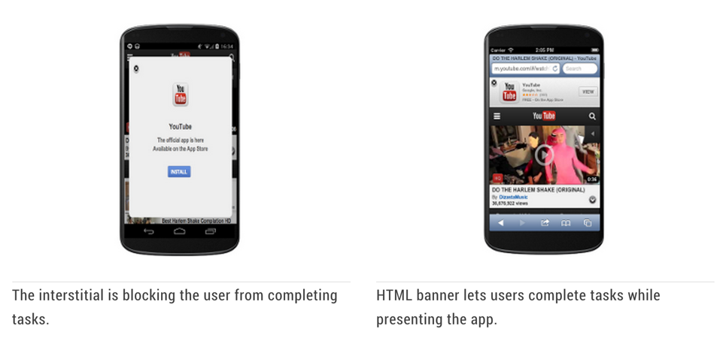
It’s better to use a simple banner to prompt a visitor to download your app, while still serving up your mobile page. You can read more about what Google has to say on this issue here.
[/INVESTIGATE]

Irrelevant cross links
[INVESTIGATE] Some sites with separate mobile sites like to have links to the desktop-optimized version and vice versa. A common error is to have links point to an irrelevant page, such as the homepage. Check your links to make sure that they point to the correct equivalent page.

Site’s media queries have unusual breakpoints
[INVESTIGATE] Using Chrome’s mobile emulator tool, pull the handle to the right to see where the media queries are set to modify the site’s template (link to animated gif). Do the breaks make sense? To learn more about Chrome’s mobile emulator tool, check out my video tutorial.

15.2 Recommendations
Recommendation 1
Recommendation 2
Recommendation 3

16.0 International
Google differentiates between multilingual and multi-regional sites. A multilingual website is any website that offers content in more than one language, whereas a multi-regional website is one that explicitly targets users in different countries. Some sites are both multi-regional and multilingual (for example, a site with different versions for the US and Canada, and both French and English versions of the Canadian content).
Expanding a website to cover multiple countries and/or languages can be fraught with challenges. Because you have multiple versions of your site, any issues will be magnified.
[CREDIT] Again, huge kudos to Aleyda Solis for providing the lion’s much of the content for this section of the audit. She is a brilliant source for all things mobile and international SEO.

16.1 Issues

Site page use combinations of translations
According to Google, they use the content language of your page to determine its language, not lang attributes. You can help Google determine the language correctly by using a single language for content and navigation on each page.
Translating only the boilerplate text of your pages, while keeping your content in a single language can create a bad user experience if the same content appears multiple times in search results with various boilerplate languages.

Site isn’t geotargeted
[INVESTIGATE]
From Google:
Targeting site content to a specific country
If Google is aware of the country targeted by a site, we can use this information to improve the quality of our search results in different countries. Google generally uses the following elements to determine a website’s targeted country:
Country-code top-level domain names (ccTLDs). These are tied to a specific country (for example .de for Germany, .cn for China), and therefore are a strong signal to both users and search engines that your site is explicitly intended for a certain country. (Some countries have restrictions on who can use ccTLDs, so be sure to do your research first.) We also treat some vanity ccTLDs (such as .tv, .me, etc.) as gTLDs, as we've found that users and webmasters frequently see these as being more generic than country-targeted (we don't have a complete list of such vanity ccTLDs that we treat as gTLDs, because such a list would change over time). See a full list of domains Google treats as generic.
Geotargeting settings. You can use the Country targeting tool in Webmaster Tools to indicate to Google that your site is targeted at a specific country. Do this only if your site has a generic top-level domain name. However, don’t use this tool if your site targets more than a single country. For example, it would make sense to set a target of Canada for a site about restaurants in Montreal; but it would not make sense to set the same target for a site that targets French speakers in France, Canada, and Mali.
Note: Because regional top-level domains such as .eu or .asia are not specific to a single country, Google treats them as generic top-level domains.
Server location (through the IP address of the server). The server location is often physically near your users and can be a signal about your site’s intended audience. Some websites use distributed content delivery networks (CDNs) or are hosted in a country with better webserver infrastructure, so it is not a definitive signal.
Other signals. Other sources of clues as to the intended audience of your site can include local addresses and phone numbers on the pages, the use of local language and currency, links from other local sites, and/or the use of Google My Business (where available).
Is the site language oriented or geographically oriented? Directories (e.g.: yourbrand.com/es/ or yourbrand.com/de/) are a better solution for language targeting — with no geographic constraint —and ccTLDs (yourbrand.es or yourbrand.de) for geographically segmented users.
[/INVESTIGATE]

Site has mismatched hreflang and canonicals
[INVESTIGATE]
From John Mueller on Google+:
For those of you using hreflang for international pages: Make sure any rel=canonical you specify matches one of the URLs you use for the hreflang pairs. If the specified canonical URL is not a part of the hreflang pairs, then the hreflang markup will be ignored.
In this case, if you want to use the "?op=1" URLs as canonicals, then the hreflang URLs should refer to those URLs. Alternately, if you want to use just "/page", then the rel=canonical should refer to that too.
Finally, don't use a rel=canonical across languages/countries, only use it on a per-country/language basis (don't specify the "de" page as the canonical for the "en" version, otherwise we won't index the "en" version).
There's much more about using hreflang on homepages at http://googlewebmastercentral.blogspot.ch/2014/05/creating-right-homepage-for-your.html & a lot of information in our help center at https://support.google.com/webmasters/answer/189077.
Edit: Some people asked about ways to recognize these issues on their site -- you can do that by using the hreflang tool as described in http://googlewebmastercentral.blogspot.ch/2014/07/troubleshooting-hreflang-annotations-in.html﻿.
[/INVESTIGATE]

Site uses geo parameters
[INVESTIGATE] Google discourages the use of query parameters to target a particular region (e.g., mysite.com/loc=de).

Site blocks search engines access to international sites
[INVESTIGATE]
If you have different versions of your site, don’t block search engines from the different geo-targeted versions of your site using robots.txt or noindex. Instead, pick a preferred version of your site and use a combination of rel=”canonical” and rel=”alternate” to let Google know where to find the different versions of the site.
Google provides three options for implementing language annotations:
HTML link element in header. In the HTML <head> section of http://www.example.com/, add a link element pointing to the Spanish version of that webpage at http://es.example.com/, like this:
<link rel="alternate" hreflang="es" href="http://es.example.com/" />
HTTP header. If you publish non-HTML files (like PDFs), you can use an HTTP header to indicate a different language version of a URL:
Link: <http://es.example.com/>; rel="alternate"; hreflang="es"
To specify multiple hreflang values in a Link HTTP header, separate the values with commas like so:
Link: <http://es.example.com/>; rel="alternate"; hreflang="es",<http://de.example.com/>; rel="alternate"; hreflang="de"
Sitemap. Instead of using markup, you can submit language version information in a Sitemap.
Source
[/INVESTIGATE]

Multiple versions of the site target the same language
[INVESTIGATE] If multiple versions of the site target the same language, such as English for Canadian and US sites or Spanish for Mexican and Spanish sites, you need to make sure the sites are unique to their respective countries to avoid duplication. Search engines don’t want to store multiple versions of an identical site in their indices.

Language not specified in HTML doctype declaration
[INVESTIGATE] According to w3.org, your site’s language should be declared in your HTML using the language attribute of the html tag. You can read more here.

International versions of the site lack country-specific links
[INVESTIGATE] One signal the search engines look for is links from the country/ies you’re targeting. You will want to make sure you build country-specific links to these versions of your site.

Russian or Chinese version of site doesn’t use correct ccTLD
[INVESTIGATE] Baidu and Yandex show preferential treatment to their respective Country Code Top Level Domains (ccTLD), so you should use the .cn and .ru ccTLDs when targeting China and Russia, respectively.

16.2 Recommendations
Recommendation 1
Recommendation 2
Recommendation 3

17.0 Business

17.1 Issues

Site hasn’t been submitted to Google My Business
[INVESTIGATE] If the site hasn’t been submitted to Google My Business, it needs to be. If you have multiple brick-and-mortar locations, you’ll need to use Google’s bulk uploader. You can use Moz Local to search for the listings for a client with brick-and-mortar locations (or acceptable alternatives).

Site hasn’t been submitted to Bing Places
[INVESTIGATE] If the site hasn’t been submitted to Bing Places, it needs to be. If you have multiple brick-and-mortar locations, you’ll need to use Bing’s bulk uploader.

Multiple locations are listed on the same page
[INVESTIGATE] The site should have a page for each location and submit each of those to Google and Bing.

Site is missing a favicon
A site’s favicon is a great branding opportunity. You can create one using the favicon.cc tool, or take a piece of your logo and reduce it to 16x16px.

Site is in a bad neighborhood
[INVESTIGATE] You can use Majestic’s Neighbourhood Checker.

17.2 Recommendations
Recommendation 1
Recommendation 2
Recommendation 3

18.0 Social

18.1 Issues

Communication on social is too commercial
[INVESTIGATE] Communication on social media should be interactive and personable. Bring to the client’s attention if their communication is one way, too salesy, or aloof.

Social accounts reply more to social influencers than customers
[INVESTIGATE] Does the client only reply to people on social with influence? If so, this could leave a bad impression with fans.

Social accounts don’t reply to criticisms on social
[INVESTIGATE]
Do a search using Twitter’s advanced search. Look for tweets that contain words like hate, angry, mad, pissed, suck, sucks, and wish with the client’s brand terms.
I did this search on Twitter for Best Buy:
Here’s an example of someone complaining on Twitter about Best Buy canceling their order. Best Buy didn’t respond, which just intensifies customer dissatisfaction. Encourage the client to draw the customer into a private interaction.
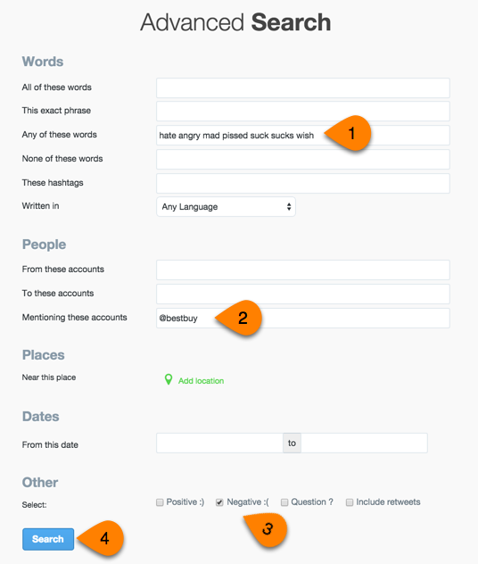
[/INVESTIGATE]

Social accounts don’t respond graciously to compliments
[INVESTIGATE] I’m a huge fan of Evernote, but I stopped tagging them on social media because they never once replied to a compliment. Here’s an example of this kind of lost opportunity. This is an epic fail for a brand. Four brands that do an outstanding job responding to fans are Buffer, Moz, JetBlue, and Screaming Frog. They are to be emulated.

Site doesn’t take advantage of Twitter Cards markup
[INVESTIGATE]
Twitter Cards make shared content on Twitter more attractive and potentially more engaging. Here is a tweet without a Twitter card:

This is what a tweet looks like with a basic summary card:
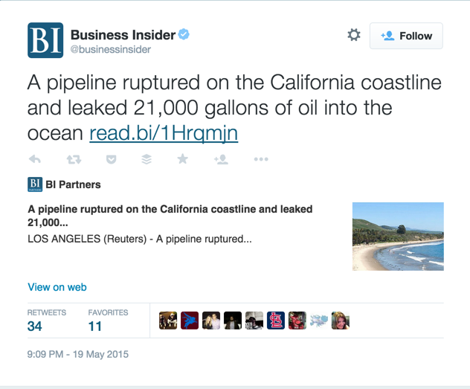
And this is what a tweet looks like with a summary large image card (the optimal option):
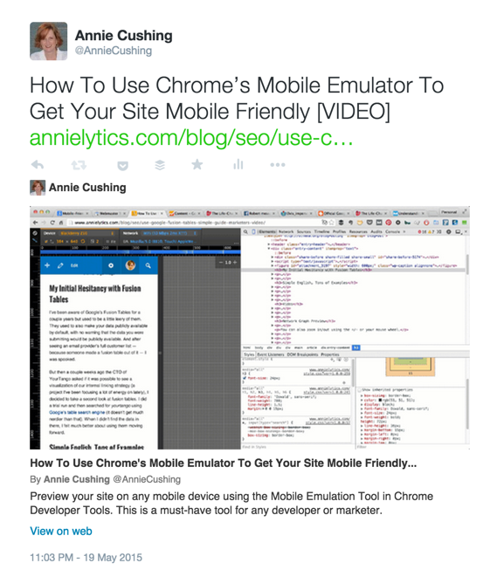
The easiest way to see if your client’s site is using Twitter Cards markup is to use the Mozbar. Just follow the steps in the screenshot below.
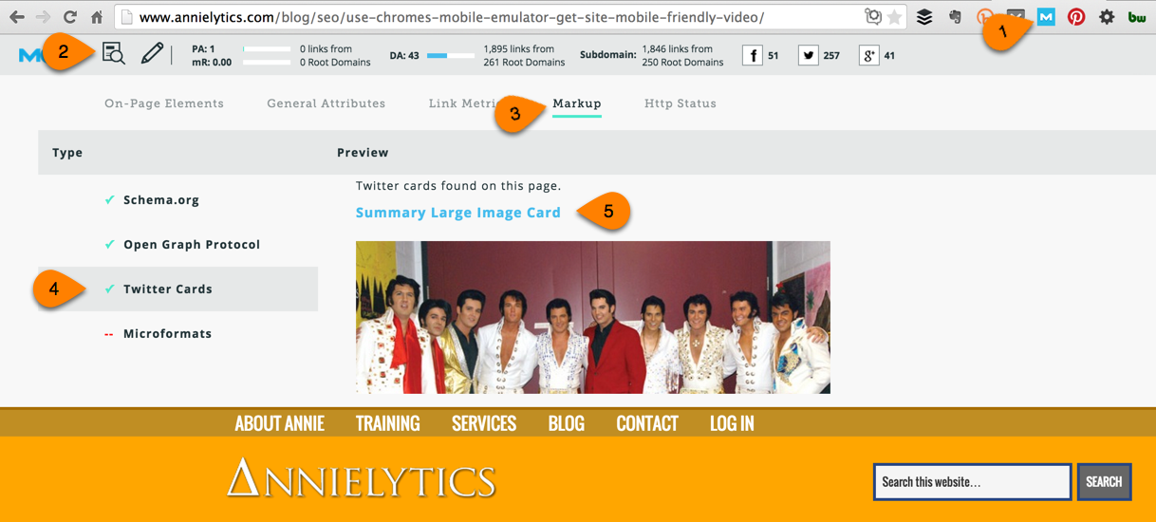
A few notes:
- Make sure the image in your post that the Twitter card will pull from is at least 120 x 120px (rectangular images work best) and under 1mb in size.
- You can use a custom image in your Twitter Card. The only site I’ve seen do this is Moz, as you can see in the example below. They actually have image templates they use and customize for each blog post they publish.

If you click through to the page, you won’t find this image on the page.
- Buffer published an excellent Twitter Cards guide you should check out.
[/INVESTIGATE]

Site doesn’t take advantage of Facebook Open Graph markup
[INVESTIGATE]
This is what a Facebook share looks like without Open Graph markup:
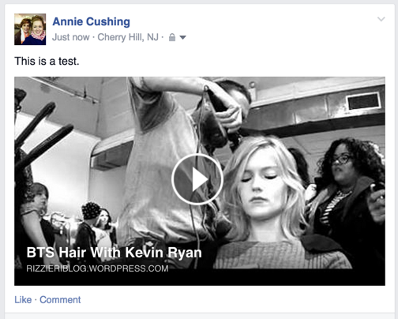
And this is what it looks like with a site that uses OG markup:
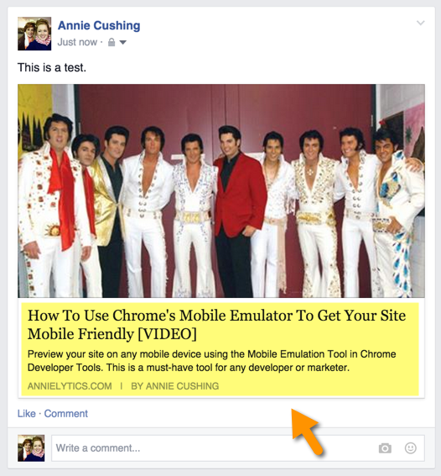
Take note the inclusion of the post’s title, description, domain, and author name (yours truly).
You can follow the steps below using the Mozbar to see if a page is tagged with OG markup:
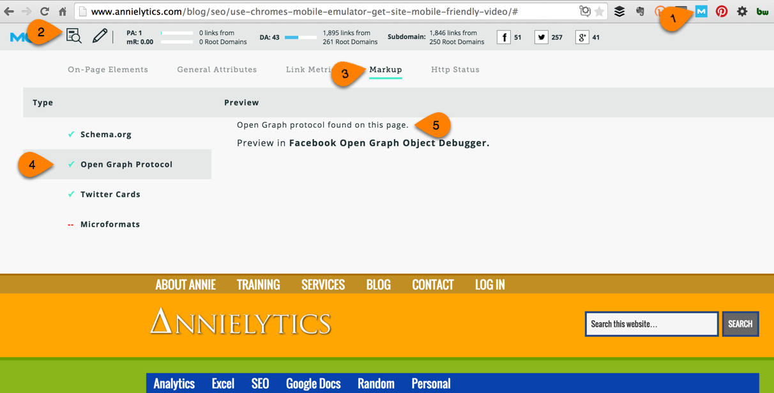
If you click through to the OG Object Debugger, you’ll see errors and even a preview of how your page would look if shared on Facebook.
One other thing to note is that Google+, LinkedIn, and Pinterest also use Open Graph markup, so setting this up is like scoring a buy-one-get-three-free sale.
[/INVESTIGATE]

Content that’s performed best in social
[INVESTIGATE]
Buzzsumo is a great tool to find a site’s top social media content. Just enter the site and scroll to see the content that’s generated the most social shares by social network for the time period you’ve selected.
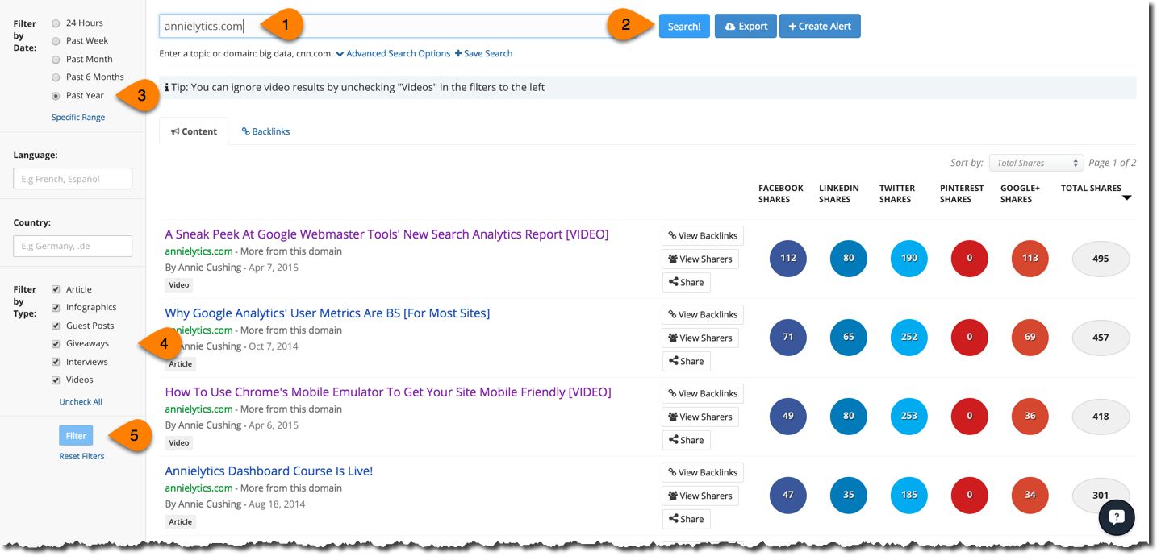
[/INVESTIGATE]

Social networks that perform best on your site
[INVESTIGATE]
There are a number of social reports in Google Analytics that effectively measure traffic from social media networks. My favorite is the Social Network report that you get to through the Channels report (Acquisition > All Traffic > Channels > Click on Social). This report is much more effective than looking at the Referrals or Source/Medium reports (under Acquisition > All Traffic) because it clusters all traffic from each network, whereas traffic from Facebook alone may be fragmented into four line items in the Referrals or Source/Medium reports.
I also like it better than the Network Referrals report (Acquisition > Social > Network Referrals) because I find the All Sessions chart really distracting and unnecessary noise.
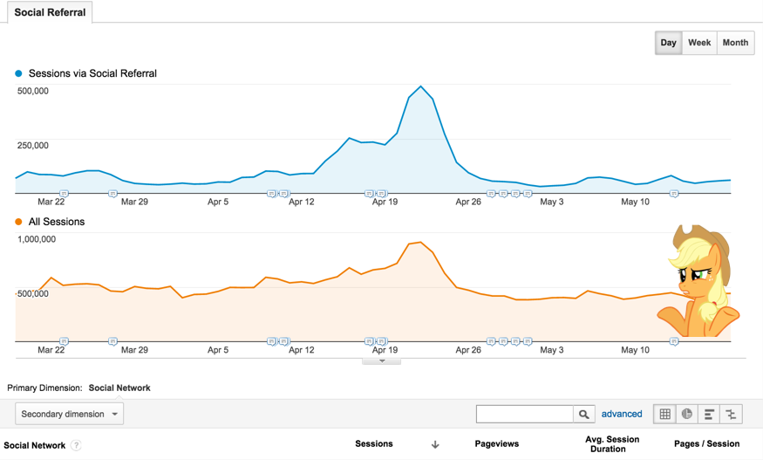
Compare metrics like bounce rate, pages/session, avg session duration (geek speak for time on site), goal completions, and revenue.
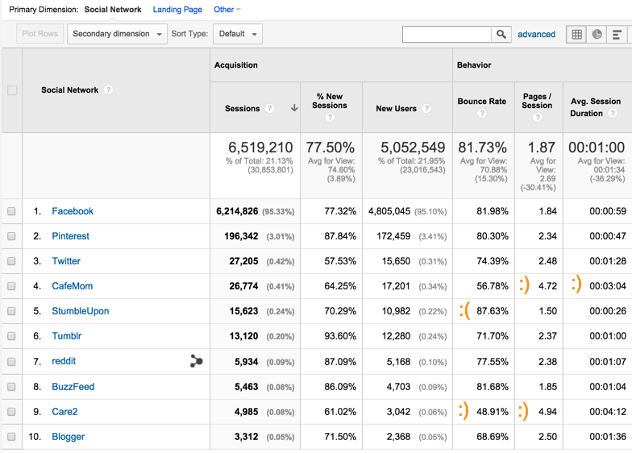

18.2 Recommendations
Recommendation 1
Recommendation 2
Recommendation 3

